## Project Report

On

## EnigmaEdu Application

Project work submitted in partial fulfilment of the requirement for the award of the degree.

## Bachelor of Computer Applications

By

**ANUMATHI SINGH (107221861004)**



**BHAVAN’s VIVEKANANDA COLLEGE OF SCIENCE, HUMANITIES & COMMERCE**

# SAINIKPURI, SECUNDERABAD – 500094

Re-Accredited with ‘A’ Grade by NAAC Autonomous College – Affiliated to Osmania University

3

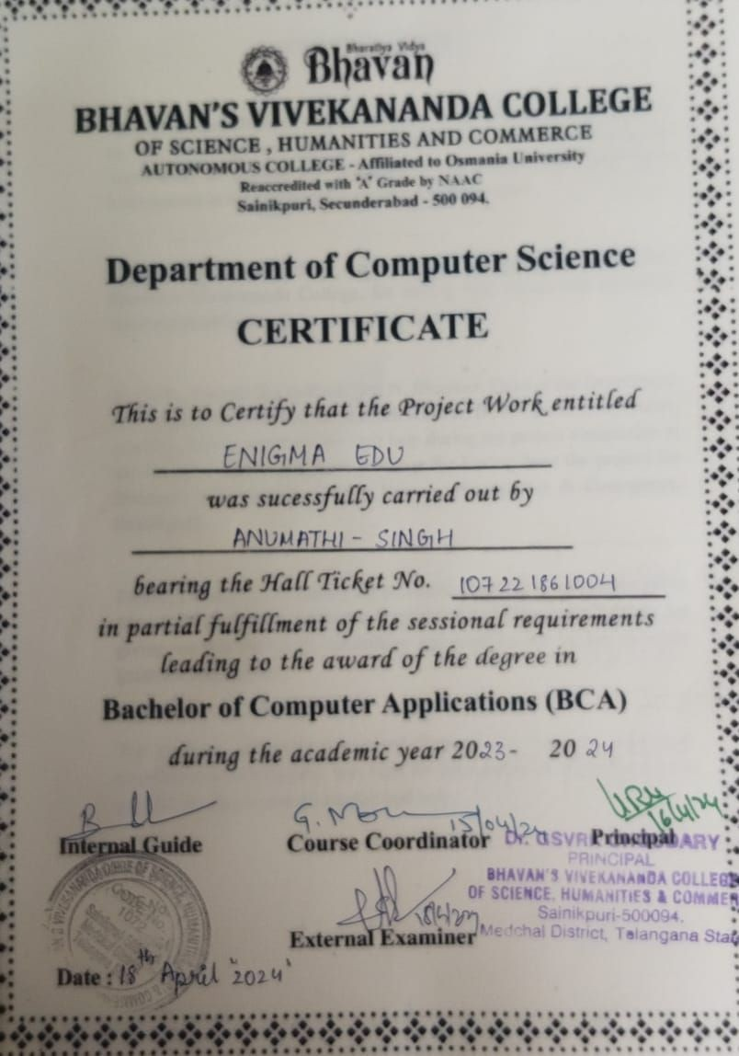

# ACKNOWLMENT

Apart from the efforts of me, the success of any project depends largely on the encouragement and guidelines of many others. I take this opportunity to express my gratitude to the people who have been instrumental in the successful completion of the project.

Firstly, I would like to thank our Principal, **Dr.G.S.V.R.K. Choudary**, Bhavan’s Vivekananda College, for having faith in me and believing thatI am capable enough to go on with the project.

Secondly, I would like to thank **Dr. N. Bhaskar**, Head of the Department of Computer Science, **Mr. G. Mahesh Kumar**, BCA Course Coordinator, and other faculty members for their help during my project completion in the college. I take it as a great privilege for having done the project for **Bhavan’s Vivekananda College Science, Humanities & Commerce, Sainikpuri**.

Finally, I would like to convey my profound gratitude to my project guide **Mrs. B Divya Rekha, Lecturer, Department of Computer Science** for giving me this project in the college and enabling me by her valuable guidance and support.

The guidance and support received from all the members who have contributed to this project, was vital for the success of the project. I am grateful for their constant support and help.

**ANUMATHI SINGH (107221861004)**

# DECLARATION

I hereby declare that the project work entitled **“EnigmaEdu”** submitted to the Bhavan’s Vivekananda College, Sainikpuri, Secunderabad, is a record of an original work done by me under the guidance of

**Mrs. B Divya Rekha**, Lecturer, Department of Computer Science, Bhavan’s Vivekananda College, Sainikpuri, Secunderabad.

I further certify that the work has not been submitted to any other Institution for the award of any degree or diploma.

**ANUMATHI SINGH (107221861004)**

# ABOUT THE ORGANIZATION

Bhavan's Vivekananda College of Science, Humanities and Commerce was in 1993 under the aegis of the Bharatiy Vidya Bhavan. Ever since its inspection, the college has been providing quality education to all students in large variety of courses. The college continues to provide all students a solid foundation for further educational opportunities and the skill for various career opportunities upon graduation.

The college offers a peaceful atmosphere, which is ideal for academic pursuits and for the overall development of the students. The college seeks to integrate the student's program of study and the development of skills, which includes critical thinking, problem solving, written and oral communication and encouraging research techniques in various fields. It seeks to learn, to adapt and to lead in the creation of a pool of committed and competent individuals indicated to the process of nation building.

The college has a dedicated set of staff, lecturers and support staff. The lecturers, apart from teaching, also imbibed in principles of discipline, commitment and hard work and to strive towards achieving the goals. They support the students in all possible ways and help students to solve their various problems and encourage the students to perform well in both academics and other co-curricular activities. Overall, the college, with its holistic atmosphere aided for learning, the principles and values that are imbibed into the students, the excellent staff headed by an able and strong Principle dedicated to making students the citizens of the future, Bhavan's Vivekananda College of Science, Humanities and Commerce is the college, where we enter in as students and pass out as moulded and well- read person, ready to take on the challenges that come by us in the future.

# INDEX

|  |  |  |
| --- | --- | --- |
| **S.No.** | **TOPIC** | **Page Number** |
| 1. | **Abstract** | 6 |
| 2. | **Problem Statement** | 7-8 |
| 3. | **Proposed System** | 9 |
| 3.1 | Overview & Goals | 9 |
| 3.2 | Modules | 10-11 |
| 4. | **System Requirement** | 12 |
| 4.1 | Software Requirement | 12 |
| 4.2 | Hardware Requirement | 12 |
| 5 | **Software Used** | 13-15 |
| 6 | **System Analysis** | 16 |
| 6.1 | Entity-Relationship Diagram | 16-23 |
| 6.2 | Data Flow Diagram | 23-25 |
| 7 | **System Design** | 26 |
| 7.1 | Class Diagram | 26-31 |
| 7.2 | Activity Diagram | 32-36 |
| 7.3 | Use Case Diagram | 37-38 |
| 7.4 | Sequence Diagram | 39-41 |
| 7.5 | Deployment Diagram | 41-43 |
| 8 | **Admin Screen** | 44-52 |
| 9 | **User Screen** | 53-62 |
| 10 | **Sample Code** | 63-81 |
| 11 | **Testing** | 82-83 |
| 12 | **Implementation** | 84 |
| 13 | **Maintenance** | 85 |
| 14 | **Conclusion** | 86 |
| 15 | **Bibliography** | 87 |

1. **ABSTRACT**

The rapid evolution of technology has significantly impacted the education sector, leading to the emergence of innovative approaches to learning. **E-Learning applications** have become integral tools in facilitating accessible and personalized education. This abstract outlines the key components and features of an advanced E- Learning app designed to enhance the learning experience for users.

The E-Learning app aims to provide a comprehensive and interactive platform that caters to diverse educational needs.

This abstract introduces an innovative E-Learning App designed to revolutionize the educational experience. Developed with a user-centric approach, the app aims to provide a dynamic and engaging platform for students and instructors alike.

The app offers a diverse set of modules, including user registration, course management, content delivery, assessments, and communication tools. Through a seamless and intuitive interface, users can navigate a rich ecosystem of educational resources tailored to their learning needs.

Efficient data management techniques ensure optimal performance and scalability. Real-time progress tracking, interactive assessments, and collaborative project features contribute to a holistic learning experience.

The E-Learning App prioritizes accessibility and convenience, allowing users to access course materials offline. The platform also incorporates features such as certification issuance and badges to recognize and motivate learners.

With a focus on security and transparency, the app implements a secure authentication system and provides centralized fee payment for user convenience. Real-time notifications keep users informed about important updates and deadlines. In summary, this E-Learning App aspires to redefine online education by offering a versatile, secure, and enriching platform. It envisions a future where learning is not just a process but a personalized and collaborative journey for all.

# PROBLEM STATEMENT

In the rapidly evolving landscape of education, traditional methods of learning are being complemented and often replaced by online platforms. E-learning apps have gained popularity for their accessibility and flexibility, offering a wealth of educational resources. However, the challenge lies in providing a personalized and effective learning experience for each student.

The existing e-learning platforms often lack the ability to adapt to individual learning styles, pace, and preferences, leading to a one-size-fits-all approach that may not cater to the diverse needs of learners

### Key Challenges:

**User Engagement and Experience:**

Issue: The current E-Learning platforms lack user-friendly interfaces and interactive features.

Impact: This deficiency results in reduced engagement and an ineffective learning experience.

### Diversity in Course Offerings:

Issue: There is a limitation in the variety of courses available, with rigid learning paths.

Impact: Users face difficulty accessing a broad range of courses tailored to their individual preferences and skill development needs.

### Efficient Content Delivery:

Issue: The existing content delivery systems are inefficient, particularly in providing multimedia-rich educational content.

Impact: A lack of dynamic and engaging content delivery hampers the overall learning experience, limiting the effectiveness of educational materials.

### Assessment and Progress Tracking:

Issue: The current E-Learning platforms lack effective tools for assessments and real-time progress tracking.

Impact: Instructors and students encounter challenges in measuring and enhancing learning outcomes, hindering educational effectiveness.

### Authentication and Security:

Issue: Security concerns exist in the current user authentication systems.

Impact: Weak authentication mechanisms pose risks to user data security, potentially compromising the overall integrity and privacy of the platform.

### Data Management and Scalability:

Issue: There are inefficiencies in backend data management, leading to scalability challenges.

Impact: As the user base grows, the performance of the platform may suffer, impacting the overall efficiency and responsiveness of the system.

Addressing these specific issues is essential for the development of a successful E- Learning App, ensuring a seamless, diverse, secure, and sustainable educational environment for all users.

# PROPOSED SYSTEM

### OVERVIEW and GOALS:

The E-Learning app is a versatile digital platform crafted to deliver an enriching and accessible education experience. Developed with Expo, React Native, HyGraph, and GraphQL technologies, the app caters to the needs of learners. Offering a diverse spectrum of courses, interactive content, and personalized tracking features, the app aims to redefine online learning. With a user-centric focus, the platform provides a secure, intuitive, and dynamic environment for knowledge acquisition and sharing.

### User-Centric Experience:

Goal: Prioritize user satisfaction with an intuitive and seamless interface. Objective: Enhance usability, accessibility, and overall user experience.

### Course Diversity and Management:

Goal: To create, manage, and deliver a variety of courses.

Objective: Provide a platform accommodating basic, advanced, project-based, and video courses.

### Multimedia Content Delivery:

Goal: Enhance learning through various content types, including videos and materials.

Objective: Create a multimedia-rich environment catering to diverse learning preferences.

### Progress Tracking and Reporting:

Goal: Empower users with tools to track their progress and receive detailed performance reports.

Objective: Provide transparent insights into individual learning journeys.

### Secure Authentication:

Goal: Ensure the security of user accounts through robust authentication mechanisms.

Objective: Implement secure authentication processes, including JWT and Clerk, to protect user data.

### Efficient Data Management:

Goal: Optimize backend data management using HyGraph and GraphQL for improved performance and scalability.

Objective: Enhance the efficiency of data storage, retrieval, and processing.

### Monetization and Sustainability:

Goal: Establish a sustainable business model through integration with AdMob for monetization.

Objective: Generate revenue streams to support ongoing development, maintenance, and content quality.

### Course Categories:

Basic Courses: Foundational courses for beginners. Advanced Courses: In-depth learning for experienced users.

Project-Based Courses: Practical application of knowledge through projects.

Video Courses: Learning through video content for a dynamic educational experience.

Interview-Prep: Helps you to prepare for any upcoming interviews lined up.

* 1. **MODULES:**

1. **Registration Module:** The admin will use their Gmail-ID or Google-ID, LinkedIn , GitHub IDs, which is a faculty, that will register themselves with their unique.
2. **Login Module:** The admin will use their Registered IDs as their log in credentials and will further create an Account for the user for them to access the app features.
3. **Course Module:** Divide the content into modules based on different topics or chapters.

Each module should cover a specific aspect of the subject matter.

1. **Fee Payment Module:** The payment of fees from one place itself instead of having multiple links will be enabled with this module. We will provide a payment gateway as well for easy payment of fees.
2. **Progress Tracking Module:** Implement a feature that allows users to track their progress through the course. Display completed modules, quizzes, and assignments. helps to strengths and areas for improvement.
3. **LeaderBoard Module:** User Rankings, display a leaderboard showing the rankings of users based on their performance in the course. Rank users by factors such as points earned, quiz scores, module completions, or overall progress.

Point System, Assign points to various activities within the app, such as completing modules, passing quizzes, or participating in discussions. Calculate users' total points and use them to determine their rank on the leaderboard.

# SOFTWARE REQUIREMENTS:

### Software Requirements:

The software requirements are description of features and functionalities of the target system. Requirements convey the expectations of users from the software product. The requirements can be obvious or hidden, known or unknown, expected or unexpected from client’s point of view. The software requirements for this software are as follows:-

OPERATING SYSTEM**:** Windows OS 10 and above with a web browser, and above with a web browser and all Android Supported Mobile Devices with a web browser.

FRONTEND SOFTWARE**:** REACT NATIVE, TAILWIND CSS, CSS,

VisualStudio version 2022, CLERK,EXPO GO.

BACKEND SOFTWARE**:** HYGRAPH, REACT NATIVE, VisualStudio version 2022, CLERK.

### Hardware Requirements:

All computer software needs certain hardware components or other software resources to be present on a computer. These prerequisites are known as (computer) system requirements and are often used as a guideline as opposed to an absolute rule. The most common set of requirements defined by any operating system or software application is the physical computer resources, also known as hardware, A hardware requirements list is often accompanied by a hardware compatibility list (HCL), especially in case of operating systems.

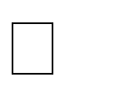**PROCESSOR:** Minimum 1GHz; Recommended 2GHz or more

**CONNECTIVITY:** Ethernet Connection(LAN) or Wireless Adapter(Wi-Fi)

**STORAGE:** 512GB SSD and 1TB HDD

**MEMORY(RAM):** Minimum 8GB; Recommended 16GB or above

**VIDEO CARD:** Minimum Intel UHD; Recommended GTX 1650ti and above

# SOFTWARE USED

The choice of technology that will be used for the development of the application is essential for its success. The technology should provide a suitable way to fulfil the requirements stated before. Principles of enterprise class applications should be kept in mind during the choice of these technologies. The two main ones are that there is no best technology but instead suitable ones and that we should not reinvent the wheel, which means that we should take advantage of what was already implemented and offered to the community.

### Frontend Software:

**Clerk:** Clerk serves as a cornerstone for frontend authentication and login systems, offering a comprehensive solution for user authentication and session management. On the frontend, Clerk ensures a seamless authentication experience by securely managing user sessions and providing robust authentication mechanisms. Its client- side libraries simplify the implementation of authentication features, such as login forms, password resets, and social login integrations, enhancing user convenience and security. Additionally, Clerk's frontend services facilitate user authorization and access control, enabling developers to define granular permissions and restrictions based on user roles and privileges. By leveraging Clerk's frontend capabilities, developers can build secure, user-friendly authentication systems that protect sensitive user data and streamline user interactions.

**Hygraph:** Hygraph empowers frontend developers with its schema design capabilities, enabling them to define and structure data effectively. By creating clear and organized data schemas, Hygraph enhances the clarity and usability of frontend components, ensuring consistency and coherence in data presentation. Frontend developers can utilize Hygraph to design intuitive user interfaces that reflect the underlying data structure accurately. Furthermore, Hygraph's frontend integration enables dynamic rendering and manipulation of data based on the defined schema, facilitating interactive user experiences and seamless data interaction. Overall, Hygraph plays a vital role in frontend development by facilitating data schema design and optimization, thereby improving the functionality and usability of frontend applications.

**GraphQL Query Language:** GraphQL queries are indispensable for frontend developers, enabling them to efficiently retrieve specific data from the server. With GraphQL, frontend components can send tailored queries to the backend API, fetching only the required data and optimizing network usage. This approach enhances app performance and responsiveness, as frontend developers can precisely control the data flow between the server and client. Moreover, GraphQL's flexible querying capabilities enable frontend developers to accommodate varying data

requirements and user preferences, ensuring a personalized and efficient user experience. By integrating GraphQL into frontend development, developers can streamline data retrieval processes, minimize latency, and build highly responsive and interactive applications.

### Backend:

**Hygraph:** In the backend, Hygraph plays a crucial role in designing and implementing data schemas, ensuring efficient storage and retrieval of data. By defining clear and structured schemas, Hygraph enhances database organization and optimization, facilitating seamless data management and manipulation. Backend developers leverage Hygraph to create scalable and adaptable data models that align with the application's requirements and objectives. Additionally, Hygraph's schema design capabilities enable developers to enforce data integrity and consistency, reducing the risk of errors and inconsistencies in the database. Overall, Hygraph contributes to the robustness and reliability of backend systems, enhancing their performance and scalability.

**GraphQL Query Language:** GraphQL is a powerful tool for backend developers, providing a flexible and efficient approach to defining. APIs and handling data queries. In the backend, developers use GraphQL to define the schema, specifying the types and fields available for query operations. This schema-centric approach streamlines API development and maintenance, as developers can easily modify and extend the schema to accommodate changing requirements. Furthermore, GraphQL's query execution engine optimizes data retrieval and processing, minimizing latency and resource consumption. Backend developers leverage GraphQL's capabilities to implement complex data fetching logic, handle authorization and authentication, and interact with various data sources, such as databases and external APIs. By adopting GraphQL in backend development, developers can build scalable, performant, and maintainable APIs that support dynamic and interactive frontend applications.

**Clerk:** Clerk's backend services are essential for managing user authentication, authorization, and data storage securely. In the backend, Clerk handles user authentication requests, verifying user credentials and generating authentication tokens or session identifiers. Additionally, Clerk manages user sessions and access control, enforcing security policies and permissions based on user roles and privileges. Backend developers leverage Clerk's authentication and authorization services to protect sensitive user data and ensure compliance with security standards and regulations. Moreover, Clerk provides robust data storage and management capabilities, allowing developers to store and retrieve user-related data securely. By integrating Clerk into the backend, developers can build scalable and secure applications that prioritize user privacy and security.

## Hardware Requirements:

All computer software needs certain hardware components or other software resources to be present on a computer. These prerequisites are known as (computer) system requirements and are often used as a guideline as opposed to an absolute rule. The most common set of requirements defined by any operating system or software application is the physical computer resources, also known as hardware, A hardware requirements list is often accompanied by a hardware compatibility list (HCL), especially in case of operating systems.

1. **Development Machine:** A computer with sufficient RAM and processing power for development.
2. **Mobile Device:** A smartphone for testing the React Native app.
3. **Server:** A server to host the GraphQL server and database.

# SYSTEM ANALYSIS

* 1. **ENTITY-RELATIONSHIP DIAGRAM**

An Entity Relationship Diagram (ERD) is a visual representation of different entities within a system and how they relate to each other. They are widely used to design relational databases. The entities in the ER schema become tables, attributes and converted the database schema. Entity relationship diagrams are used in software engineering during the planning stages of the software project. They help to identify different system elements and their relationships with each other.

Entity-Relationship Diagram (ERD) Symbols and Notations:

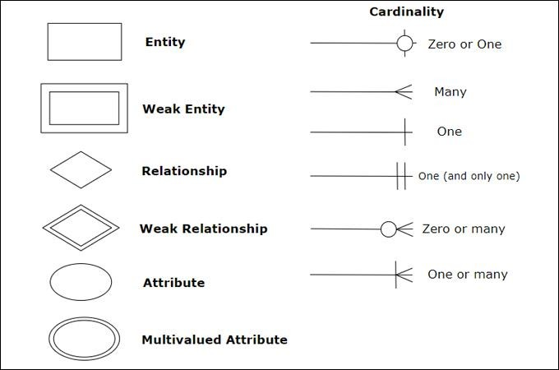

Elements in ER diagrams have three basic elements: entity, attribute, relationship. There are more elements that are based on the main elements. They are weak entity, multi valued attribute, derived attribute, weak relationship, and recursive relationship. Cardinality and ordinality are two other notations used in ER diagrams to further define relationships.

### Entity

An entity can be a person, place, event, or object that is relevant to a given system.For example, a school system may include students, teachers, major courses, subjects, fees, and other items. Entities are represented in ER diagrams by a rectangle and named using singular nouns.

### Weak Entity

A weak entity is an entity that depends on the existence of another entity. In termsthat are more technical it can be defined as an entity that cannot be identified by its own attributes. It uses a foreign key combined with its attributed to form the primary key. An entity like order item is a good example for this. The order item will be meaningless without an order so it depends on the existence of the order. Weak Entity Example in ER diagrams.

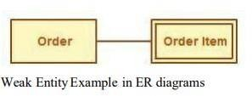

### Attribute

An attribute is a property, trait, or characteristic of an entity, relationship, or another attribute. For example, the attribute Inventory Item Name is an attribute of the entity Inventory Item. An entity can have as many attributes as necessary. Meanwhile, attributes can also have their own specific attributes. For example, the attribute “customer address” can have the attributes number, street, city, and state. These are called composite attributes. Note that some top level ER diagrams do not show attributes for the sake of simplicity. In those that do, however, oval shapes represent attributes.

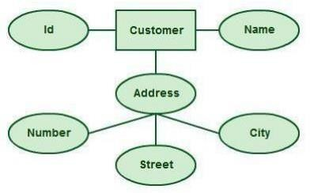

* + 1. **Simple attribute:** - An attribute is classified as a simple attribute if it cannot bepartitioned into smaller components. For example, age and sex of a person. A simple attribute is represented by an oval.
    2. **Composite attribute:** - A composite attribute can be subdivided into smaller components, which further form attributes. For example, ‘name’ attribute of an entity “person” can be broken down into first name and last name, which further form attributes. Grouping of these related attributes forms a composite attribute ‘name’ is the composite attribute in this example.

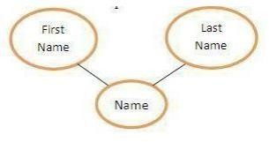

* + 1. **Single valued attribute:** - If an attribute of a particular entity represents singlevalue for each instance, then it is called a single- valued attribute. For example, Ramesh, Kamal and Suraj are the instances of entity ‘student’ and each of them isissued a separate roll number. A single oval is used to represent this attribute.
    2. **Multivalued Attribute:** - If an attribute can have more than one value, it is called a multi-valued attribute. It is important to note that this is different from anattribute having its own attributes. For

example, a teacher entity can have multiplesubject values. Example of a multivalued attribute.

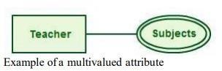

* + 1. **Derived Attribute:** - An attribute based on another attribute. This is found rarely in ER diagrams. For example, for a circle, the area can be derived from theradius. Derived Attribute in ER diagrams.

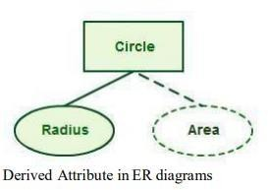

* + 1. **Relationship:** - A relationship describes how entities interact. For example, the entity “Carpenter” may be related to the entity “table” by the relationship “builds” or “makes”. Relationships are represented by diamond shapes and are labelled using verbs.

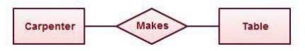

Various terms related to relationships:

1. **Degree of relationship:** - It signifies the number of entities involved in a relationship. Degree of a relationship can be classified into following types:-
   1. **Unary relationship:** - If only single entity is involved in a relationship, then it is a unary relationship. For example, an employee (manager) supervises another employee.

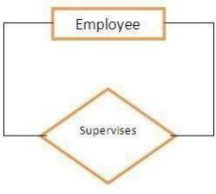

* 1. **Binary relationships:** - When two entities are associated to form a relation, then it is known as a binary relationship. For example, a person works in a company. Most of the times we use only binary relationship in an e-r diagram. The teacher-student example shown above signifies a binary relationship. Other types of relationships are ternary and quaternary. As the name signifies, a ternary relationship is associated with three entities and a quaternary relationship isassociated with four entities.

1. **Connectivity of a relationship:** - Connectivity of a relationship describes howmany instances of one entity type are linked to how many instances of another entity type. Various categories of connectivity of a relationship are-
   1. **One to One (1:1):** - “Student allotted a project” signifies a one-to-one relationship because only one instance of an entity is related with exactly one instance of another entity type.

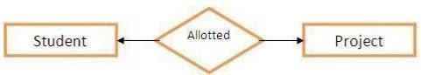

* 1. **One to Many (1:M):** - “A department recruits’ faculty” is a one-to- many relationship because a department can recruit more than one faculty, but a facultymember is related to only one department.
  2. **Many to One (M:1):** - “Many houses are owned by a person” is a many- to onerelationship because a person can own many houses but a particular house is owned only by a person.

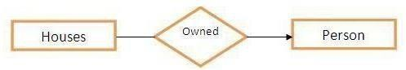

* 1. **Many to Many (M:N):** – “Author writes books” is a many-to-many relationship because an author can write many books and a book can be written by many authors.

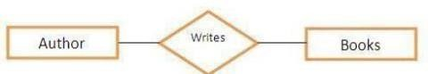

**ENTITY-RELATIONSHIP DIAGRAM FOR ENIGMAEDU:**

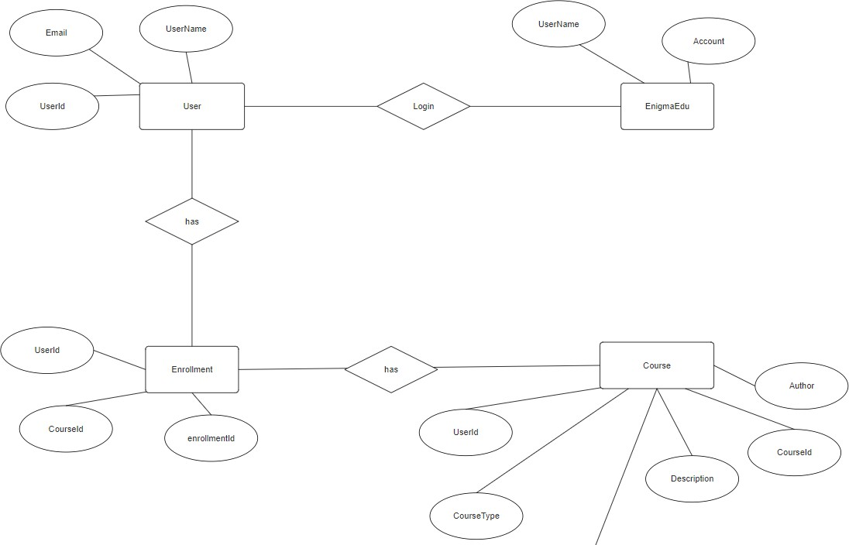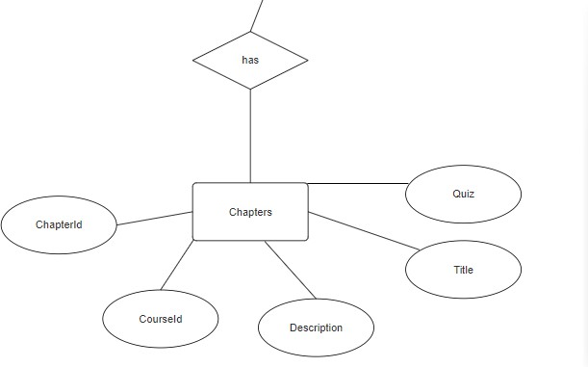

The ER diagram here analysis the data requirements with entities and attributes along with their relationships. The model provides a conceptual model approach:

The entities used and their attributes are*-*

**User:** UserId, UserName, Email **EnigmaEdu:** UserName, Account **Enrollment:** enrollmentId, UserId, CourseId

**Courses:** CourseId, Title, Description, CourseType, Author

**Chapters:**CourseId,Description,Title,ChapterId,Quiz

# DATA - FLOW DIAGRAM

* DFD is the abbreviation for Data Flow Diagram. The flow of data of a system or a process is represented by DFD. It also gives insight into the inputs and outputs of each entity and the process itself. DFD does not have control flow and no loops or decision rules are present. Specific operations depending on the type of data can be explained by a flowchart. Data Flow Diagram can be represented in several ways. The DFD belongs to structured-analysis modelingtools. Data Flow diagrams are very popular because they help us to visualize the major steps and data involved in software-system processes.
* A full description of a system actually consists of a set of data flow diagrams. Using two familiar notations Yourdon, Gane, and Sarson notation develops the data flow diagrams. Each component in a DFD is labeled with a descriptive name.

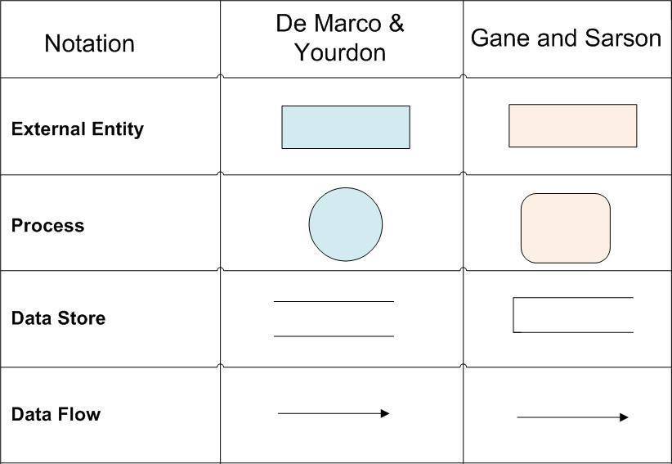

**DATA - FLOW DIAGRAM LEVEL-0**

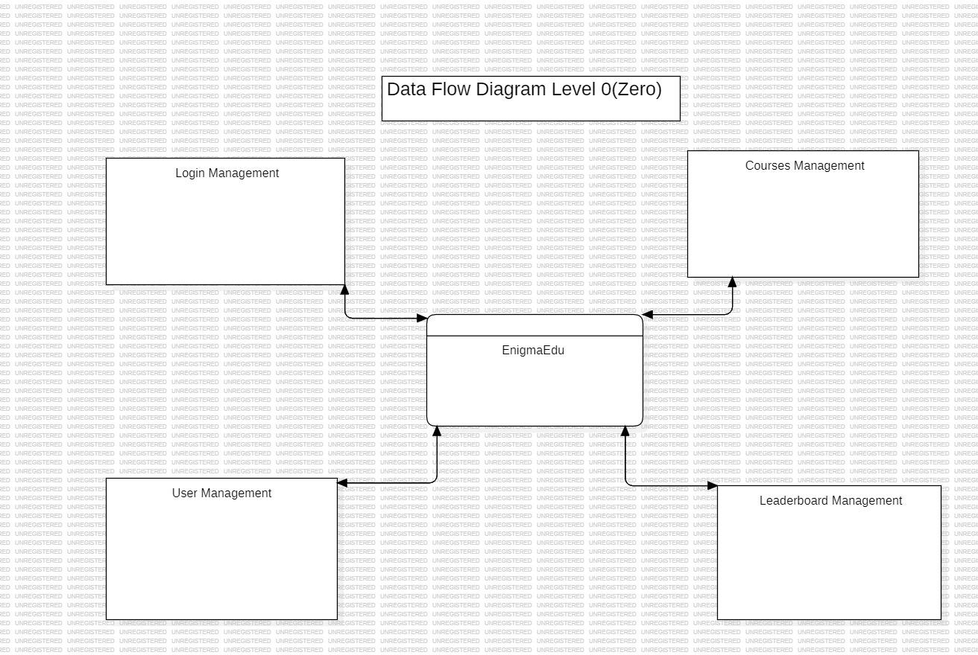

**DATA - FLOW DIAGRAM LEVEL 1**

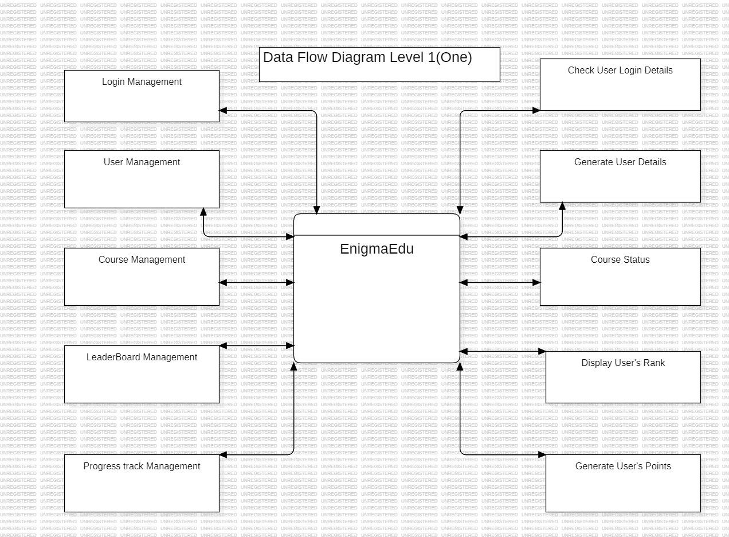

# UML DIAGRAMS

UML stands for Unified Modeling Language. This object-oriented system of notation has evolved from the work of Grady Brooch, James Rumbaugh, lvar Jacobson and the rational software corporation. These renowned computer scientists fused their respective technologies into a single, standardized model. Today, the Object Management Group (OMG) as the standard for modeling object-oriented concepts. The unified modeling notation that is governed by a set of syntactic semantic and pragmatic rules. A UML system is represented using five different views that describe the system from a distinctly different perspective. Each view is defined by a set of diagrams, which is as follows.

Types of UML Diagram we drew in this project are:

* Class Diagram
* Activity Diagram
* Use Case Diagram
* Sequence Diagram
* Component Diagram
* Deployment Diagram
* Collaboration Diagram
  1. **CLASS DIAGRAM**

The UML Class diagram is a graphical notation used to construct and visualize object- oriented systems. A class diagram in the Unified Modelling Language (UML) is a type of static structure diagram that describes the structure of a system by showing the systems:

* Classes
* their attributes,
* operations (or methods),
* and the relationships among objects.

**Class:** A Class is a blueprint for an object. Objects and classes go hand in hand. We cannot talk about one without talking about the other. In addition, the entire point of Object-Oriented Design is not about objects, it is about classes, because we use classes to create objects. Therefore, a class describes what an object will be, but it is not the object itself.

**UML Class Notation:** A class represents a concept, which encapsulates state (attributes) and behaviour (operations). Each attribute has a type. Each operation has a signature. The class name is the only mandatory information.

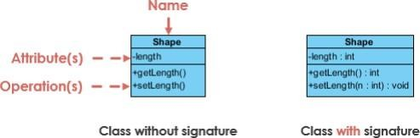

**Class Name:** The name of the class appears in the first partition.

### Class Attributes:

* Attributes are shown in the second partition.
* The attribute type is shown after the colon.
* Attributes map onto member variables (data members) in code.

### Class Operations (Methods):

* Operations are shown in the third partition. They are services the classprovides.
* The return type of a method is shown after the colon at the end of the method signature.
* The return type of method parameters are shown after the colon following the parameter name.
* Operations map onto class methods in code.

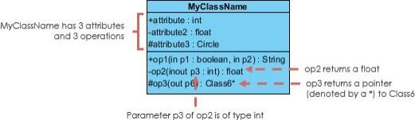

Class Visibility, the + , - and # symbols before an attribute and operation name in a class denote the visibility of the attribute and operation.

+ denotes public attributes or operations

* - denotes private attributes or operations
* # denotes protected attributes or operations.

### Relationships between classes:

**Inheritance (or Generalization):**

A generalization is a relationship between a more general classifier and a more specific classifier. Each instance of the specific classifier is also an indirect instance of the general classifier. Thus, the specific classifier inherits the featuresof the more general classifier. The figure below shows an example of inheritance hierarchy. SubClass1 and SubClass2 are derived from Superclass. The relationshipis displayed as a solid line with a hollow arrowhead that points from the child element to the parent element.

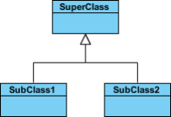

### Association:

Associations are relationships between classes in a UML Class Diagram. A solid line between classes represents them. Associations are typically named using a verb or verb phrase, which reflects the real world problem domain.

### Simple Association

* A structural link between two peer classes.
* There is an association between Class1 and Class2

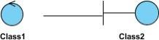

### Cardinality:

Cardinality is expressed in terms of:

* one to one
* one to many
* many to many

### Aggregation

* A special type of association.
* It represents a "part of'' relationship.
* Class2 is part ofClass1.
* Many instances (denoted by the *) of Class2 can be associated with Class1.
* Objects of Class1 and Class2 have separate lifetimes.

The figure below shows an example of aggregation. The relationship is displayed as a solid line with an unfilled diamond at the association end, which is connected to the class that represents the aggregate.

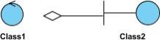

### Composition

* A special type of aggregation where parts are destroyed when the whole is destroyed.
* Objects of Class2 live and die with Class1.
* Class2 cannot stand by itself.

The figure below shows an example of composition. The relationship is displayed as a solid line with a filled diamond at the association end, which is connected to the class that represents the whole or composite.

### Dependency

* An object of one class might use an object of another class in the code of a method.
* If the object is not stored in any field, then this is modeled as a dependency relationship.
* A special type of association.
* Exists between two classes if changes to the definition of one may cause changes to the other (but not the other way around).
* Class1 depends on Class2.

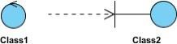

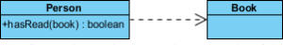

The figure below shows an example of dependency. The relationship is displayed as a dashed line with an open arrow. The figure above shows another example of dependency. The Person class might have a has Read method with a Book parameter that returns true if the person has read the book (perhaps by checking some database).

### Realization:

Realization is a relationship between the blueprint class and the object containing its respective implementation level details. This object is said to realize the blueprint class. In other words, you can understand this as the relationship between the interface and the implementing class. For example, the Owner interface might specify methods for acquiring property and disposing of property. The Person and Corporation classes need to implement these methods, possibly in very different ways.

**CLASS DIAGRAM :**

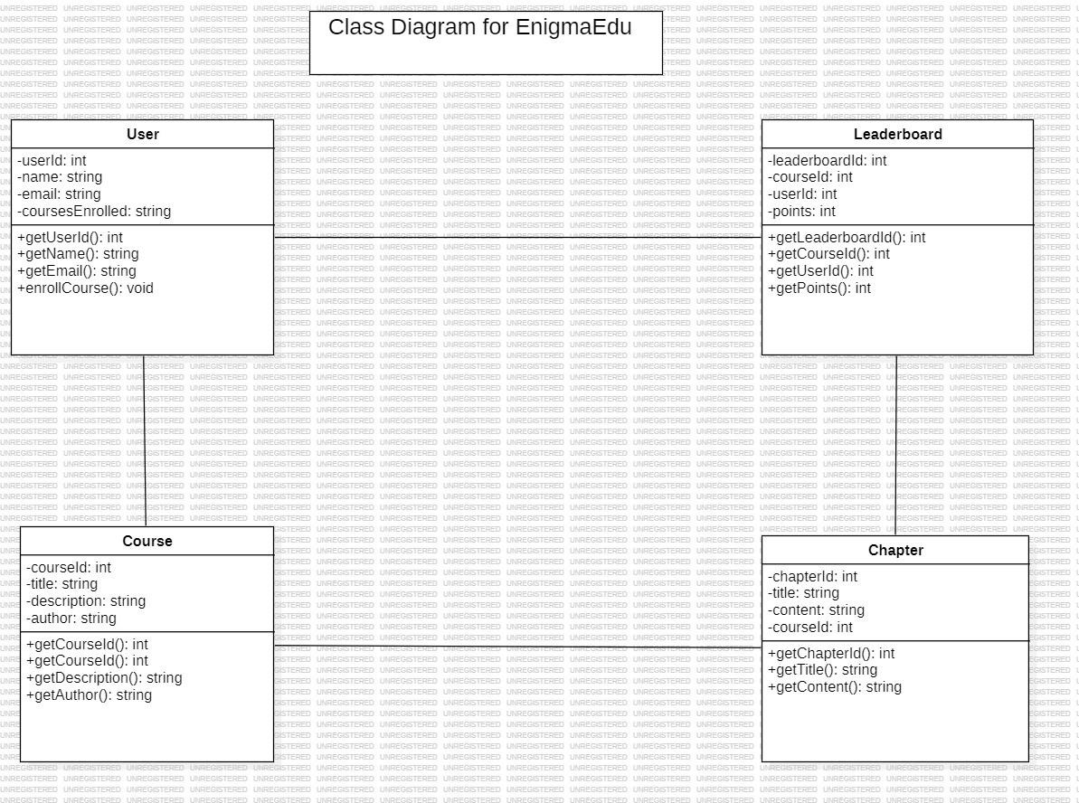

* 1. **ACTIVITY DIAGRAM**

Activity diagram is another important diagram in UML to describe the dynamic aspects of the system. Activity diagram is basically a flowchart to represent the flow from one activity to another activity. The activity can be described as an operation of the system. The control flow is drawn from one operation to another. This flow can be sequential, branched, or concurrent. Activity diagrams deal with all type of flow control by using different elements such as fork, join, etc. Purpose of Activity Diagrams: The basic purpose of activity diagrams is similar to other four diagrams. It captures the dynamic behaviour of the system. Other four diagrams are used to show the message flow from one object to another but the activity of the diagram is used to show the message flow from one activity to another. Activity is a particular operation of the system. Activity diagrams are not only used for visualizing the dynamic nature of a system, but they are also used to construct the executable system by using forward and reverse engineering techniques. The only missing thing in the activity diagram is the message part.

The purpose of an activity diagram can be described as-

* Draw the activity flow of a system.
* Describe the sequence from one activity to another.
* Describe the parallel, branched and concurrent flow of the system.

**Components of an Activity Diagram:** -

1. **Initial State or Start Point:** A small filled circle followed by an arrowrepresents the initial action state or the start point for any activity diagram.

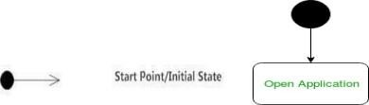

1. **Activities:** The categorization of behavior into one or more actions is termed as an activity. In other words, it can be said that an activity is a network of nodes that are 26 connected by edges. The edges depict the flowof execution. It may contain action nodes, control nodes, or object nodes. The control flow of activity is represented by control nodes and object nodes that illustrate the objects used within an activity. The activities are initiated at the initial node and are terminated at the final node.
2. 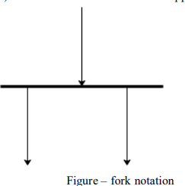**Fork** – Fork nodes are used to support concurrent activities.

When we use a fork node when both the activities get executed concurrently i.e., no decision is made before splitting the activity into twoparts. Both parts need to be. We use a rounded solid rectangular bar to represent a Fork notation with incoming arrows from the parent activity state and outgoing arrows towards the newly created activities. For example: In the example below, the activity of making coffee can be split into two concurrent activities and hence we use the fork notation.

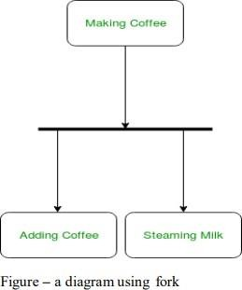

1. **Join** - Join nodes are used to support concurrent activities converging intoone. For join notations, we have two or more incoming edges and one outgoing edge.

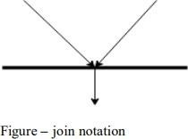

For example – When both activities i.e. steaming the milk and addingcoffee get completed, we converge them into one final activity.

1. **Action Flow** - Action flows, also called edges and paths, illustrate the transitions from one action state to another. They are usually drawn with an arrowed line.



1. **Decisions and Branching** - When we need to make a decision before deciding the flow of control, we use the decision node.

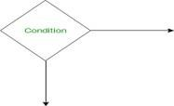

The outgoing arrows from the decision node can be labeled with conditionsor guard expressions. It always includes two or more output arrows.

1. **Guards** - A Guard refers to a statement written next to a decision node onan arrow sometimes within square brackets.

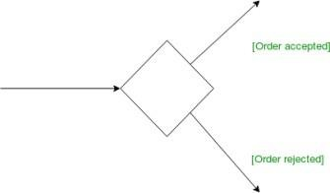

1. **Final State or End Point -** An arrow pointing to a filled circle nestedinside another circle represents the final action state.

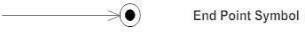

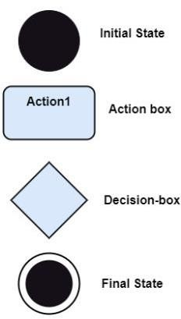

**ACTIVITY DIAGRAM:**

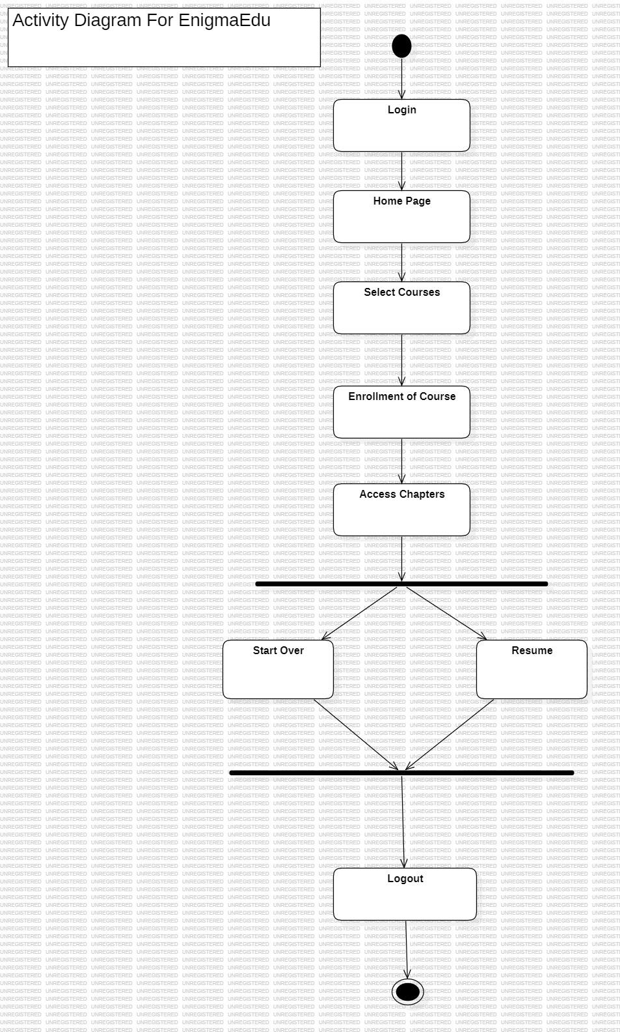

* 1. **USE CASE DIAGRAM**

In Unified Modelling Language (UML), use case diagrams are used to show the interactions between actors and a system. The system can be a website or another similar entity being developed. An actor is a person or entity that interacts with the system - normally, this is a user. In essence, use case diagrams depict the system, who is using it, how they are using it, or what they are doing. On a macro scale, the information you can glean from use case diagrams allow you to set the scope of your system or application and what goals it can help the actors achieve.

### Use case diagrams are typically used in the following scenarios:

* Depicting the scope and goal of the interactions between the actor and thesystem.
* Modeling the interactions between actors and the system, as well as the generalflow of events.
* Identifying internal or external factors that might influence the outcome of interaction and, by extension, the system itself.

### Use Case Diagram Symbols:

The notation for a use case diagram is straightforward and does not involve as many types of symbols as other UML diagrams.

* **Use cases:** Horizontally shaped ovals that represent the different uses that auser might have.
* **Actors:** Stick figures that represent the people actually employing the usecases.
* **Relationship:** A line between actors and use cases. In complex diagrams, it is important to know which actors are associated with which use cases.

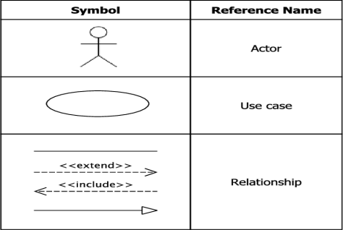

**USECASE DIAGRAM:**

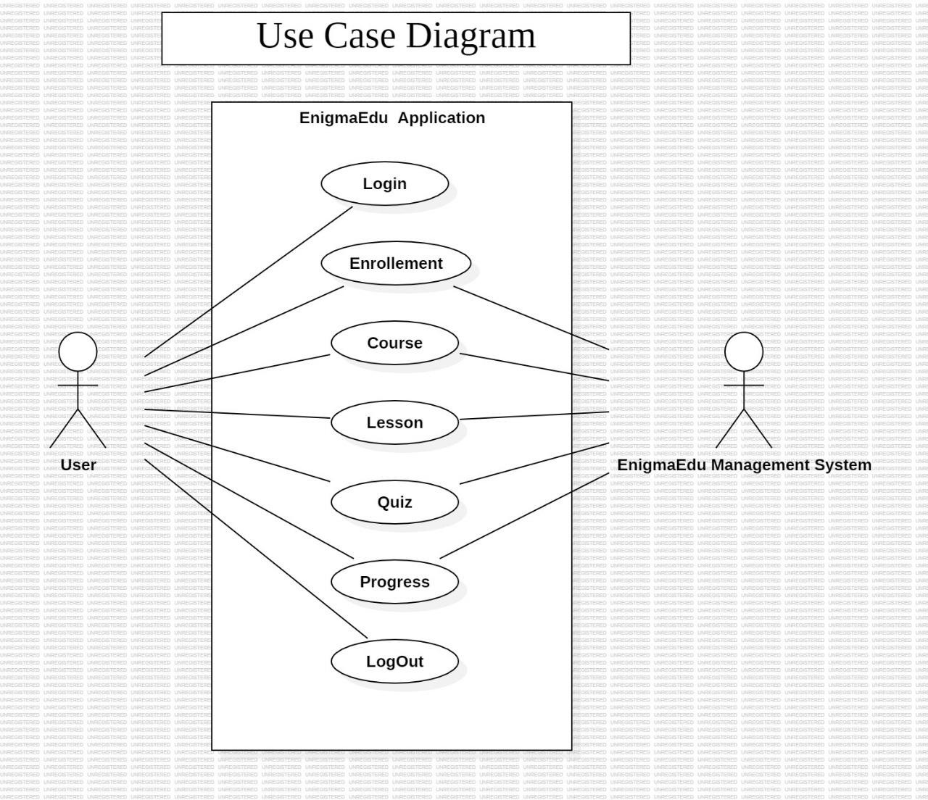

* 1. **SEQUENCE DIAGRAM**

Sequence diagrams describe interactions among classes in terms of an exchange of messages over time. They are also called event diagrams. A sequence diagram is a good way to visualize and validate various runtime scenarios. These can help to predict how a system will behave and to discover responsibilities a class may need to have in the process of modelling a new system.

### Basic Sequence Diagram Notations:-

* **Actor symbol:** Shows entities that interact with or are external to the system.

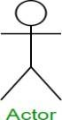

* **Activation:** Activation boxes represent the time an object needs to complete atask. When an object is busy executing a process or waiting for a reply message, use a thin grey rectangle placed vertically on its lifeline.

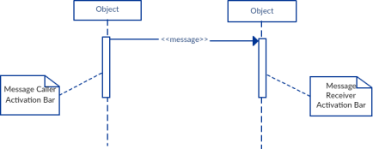

* **Messages:** Messages are arrows that represent communication between objects. We use half-arrowed lines to represent asynchronous messages. Asynchronous messages are sent from an object that will not wait for a response from the receiver before continuing its tasks.
* **Return:** A return message is used to indicate that the message receiver is done processing the message and is returning control over to the message caller. Return messages are optional notation pieces, for an activation bar that is triggered by a synchronous message always implies a return message.

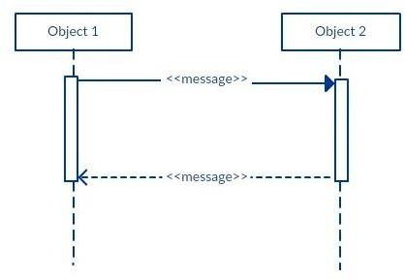

* **Lifelines:** Lifelines are vertical dashed lines that indicate the object's presence over time.
* **Comment:** UML diagrams generally permit the annotation of comments in all UML diagram types. The comment object is a rectangle with a folded-over corner as shown below. The comment can be linked to the related object witha dashed line.

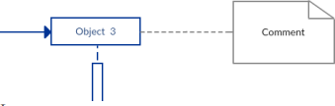

**SEQUENCE DIAGRAM:**

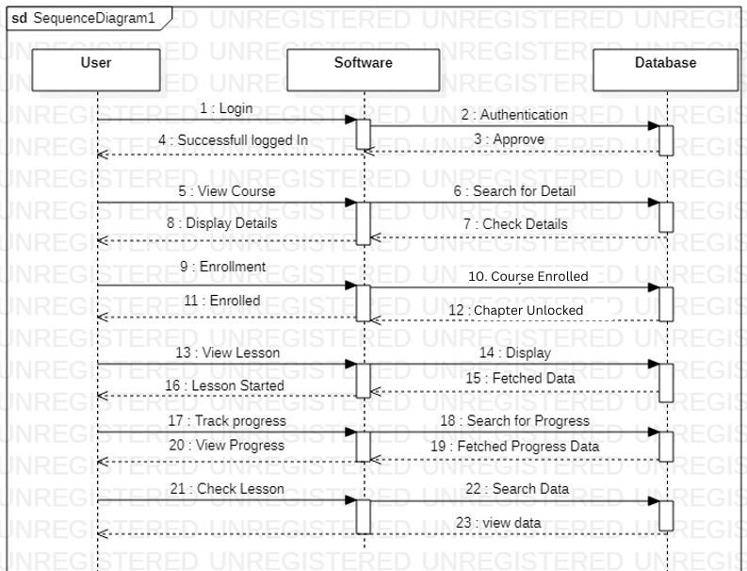

* 1. **DEPLOYMENT DIAGRAM**

A deployment diagram is a UML diagram type that shows the execution architecture of a system, including nodes such as hardware or software execution environments, and the middleware connecting them. Deployment diagrams are typically used to visualize the physical hardware and software of a system. Using it you can understand how the system will be physically deployed on the hardware. Deployment diagrams help model the hardware topology of a system compared to other UML diagram types, which mostly outline the logical components of a system.

Deployment Diagram Notations: In order to draw a deployment diagram, you need to first become familiar with the following deployment diagram notations and deployment diagram elements.

* 1. **Nodes:** A node, represented as a cube, is a physical entity that executes one ormore components, subsystems or executables. A node could be a hardware or software element.
  2. **Artifacts:** Artifacts are concrete elements that are caused by a development process. Examples of artifacts are libraries, archives, configuration files,executable files etc.
  3. **Communication Association:** This is represented by a solid line between twonodes. It shows the path of communication between nodes.
  4. **Devices:** A device is a node that is used to represent a physical computational resource in a system. An example of a device is an application server.
  5. **Deployment Specifications:** Deployment specifications is a configuration file, such as a text file or an XML document. It describes how an artifact is deployed.

**DEPLOYMENT DIAGRAM:**

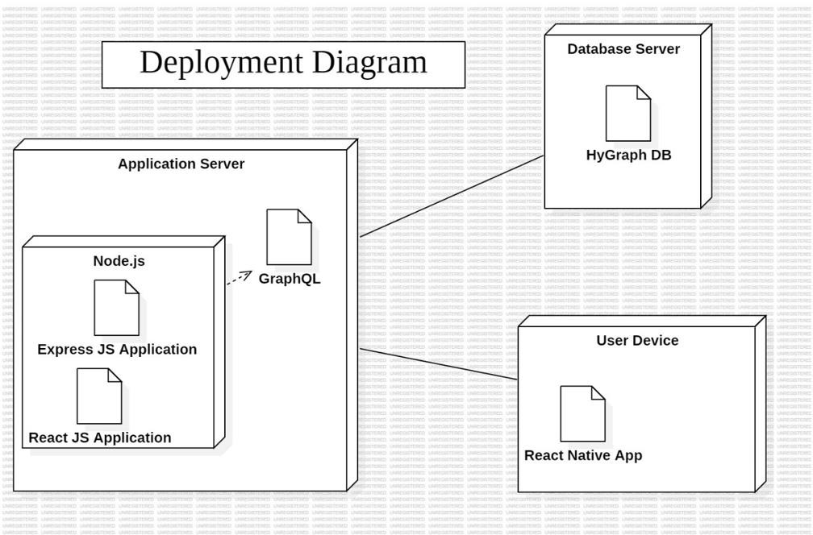

# ADMIN SCREEN(HYGRAPH)

### HYGRAPH Schema Models: Course:

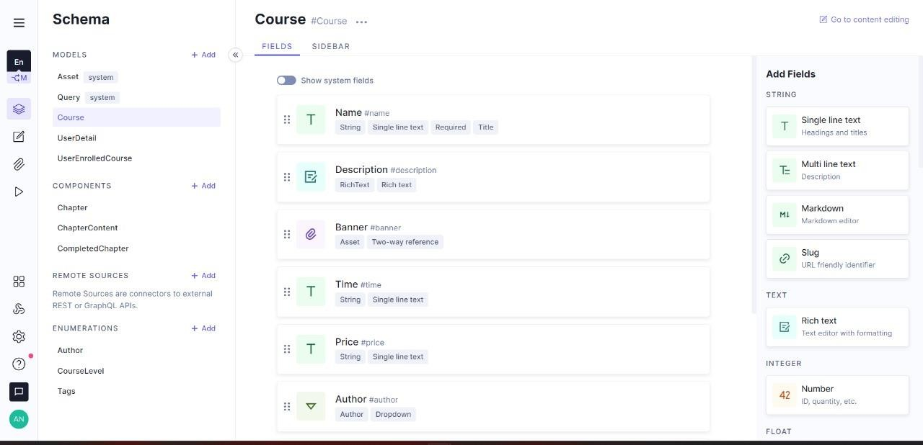

**UserDetails:**

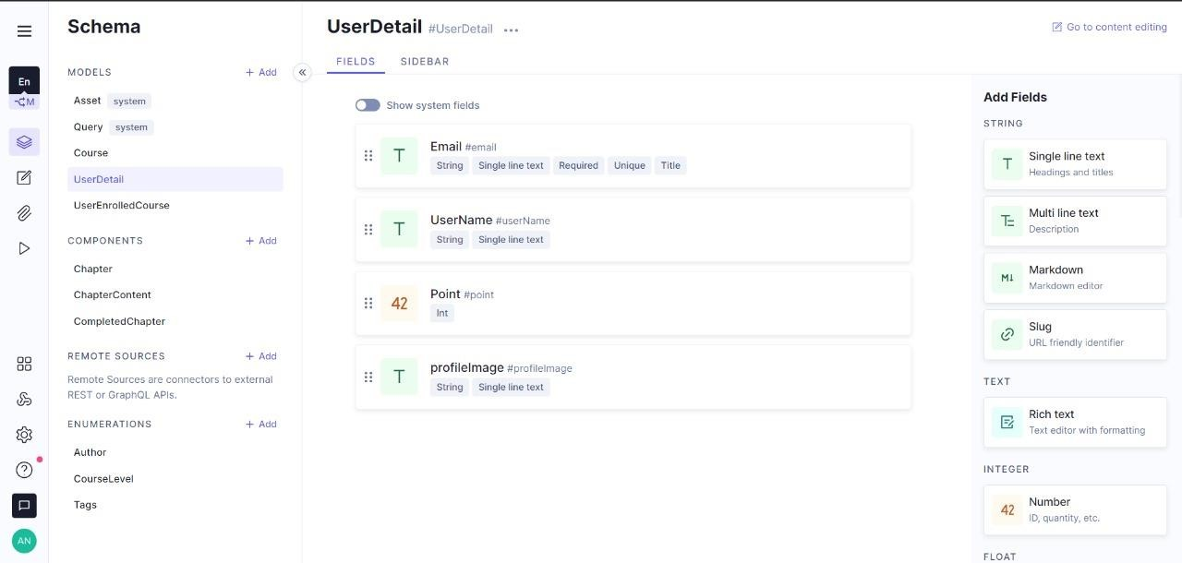

### UserEnrolledCourse:

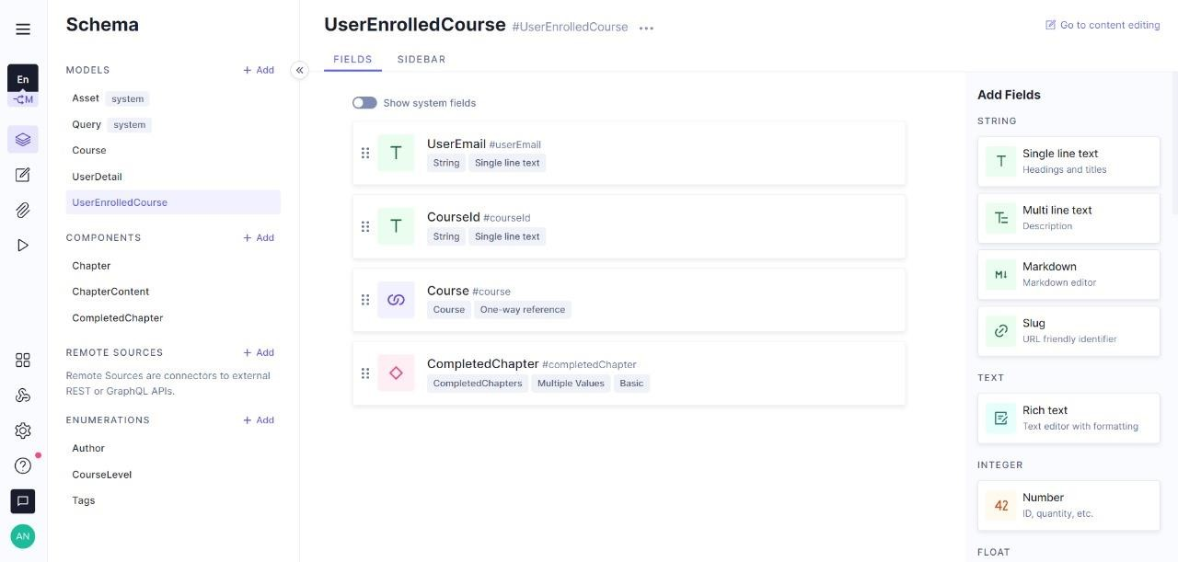

**Components:**

**Chapter:**

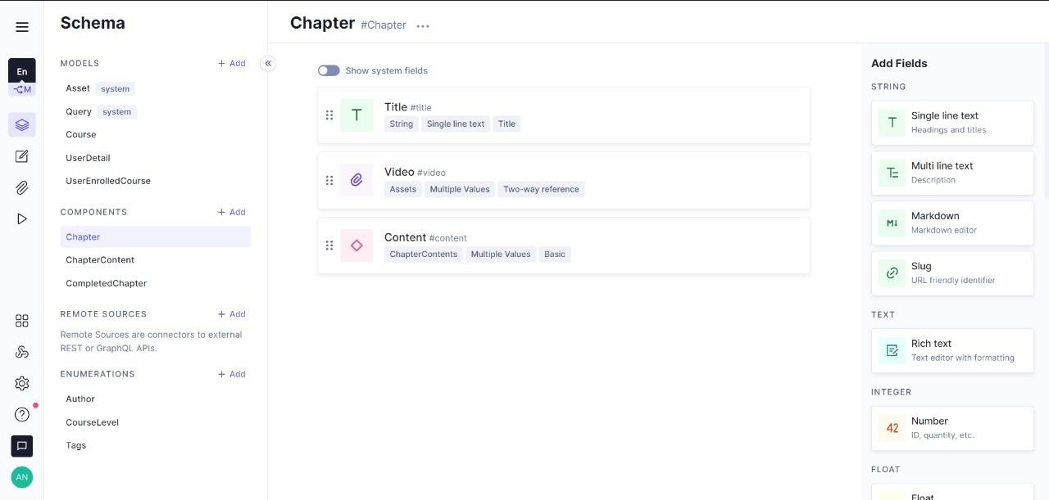

**Chaptercontent:**

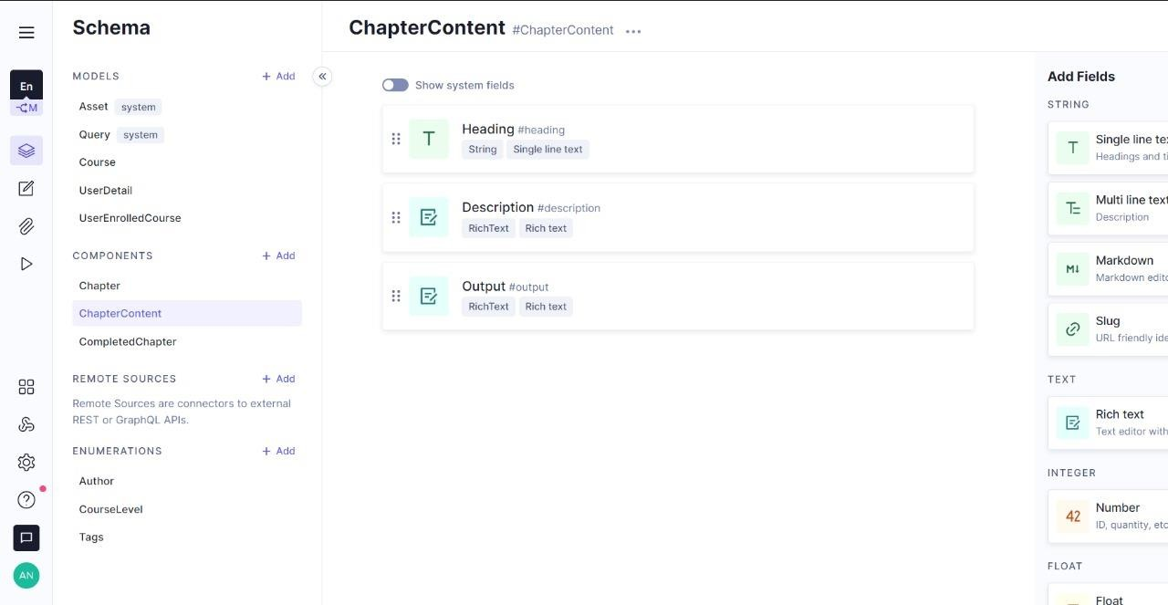

**CompletedChapter:**

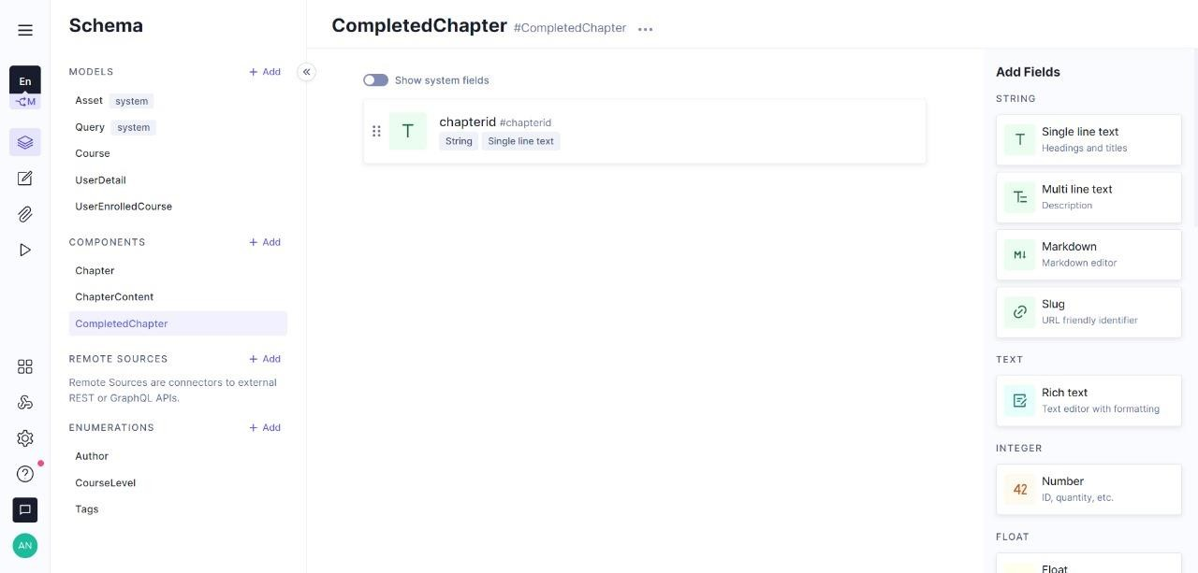

**Enumerations:**

**Author:**

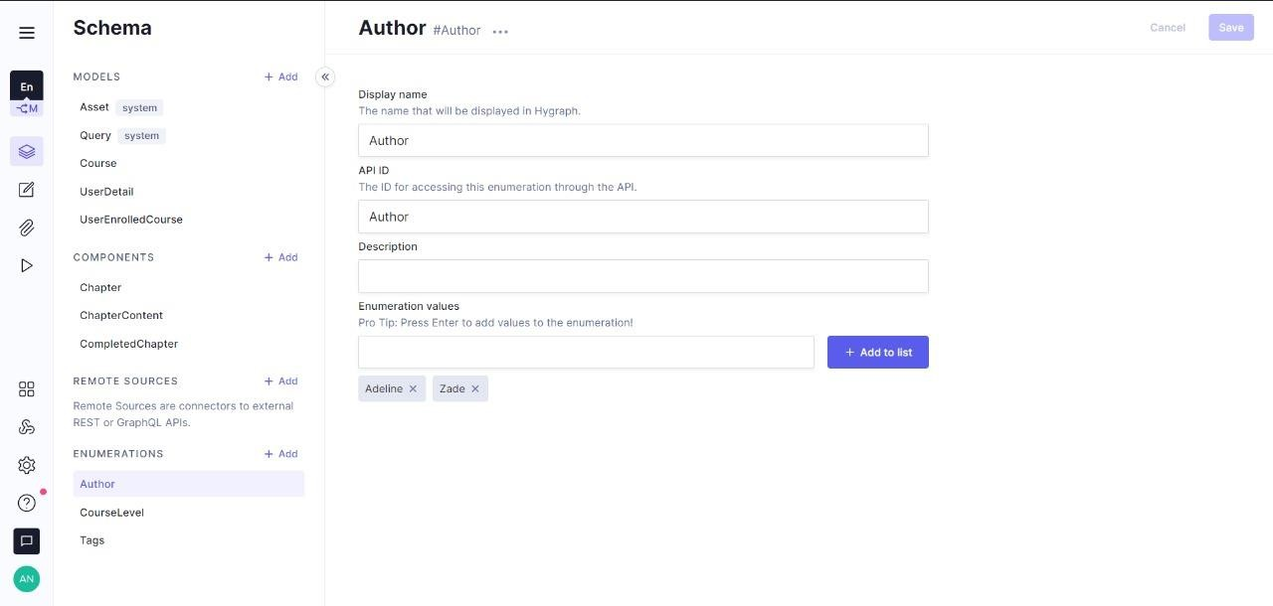

**CourseLevel:**

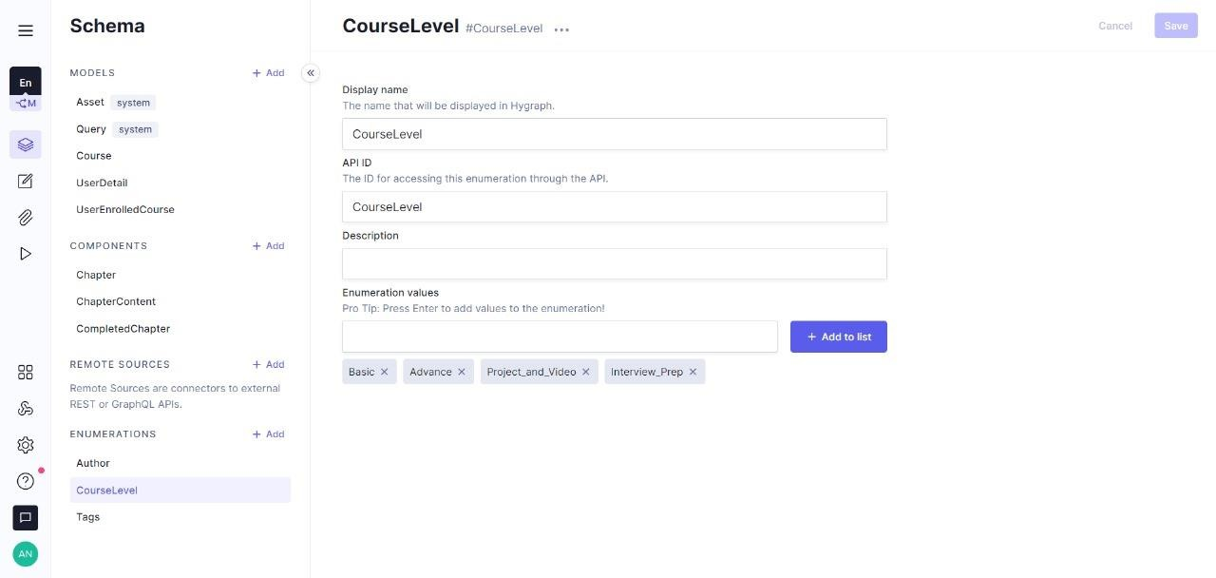

**Tags:**

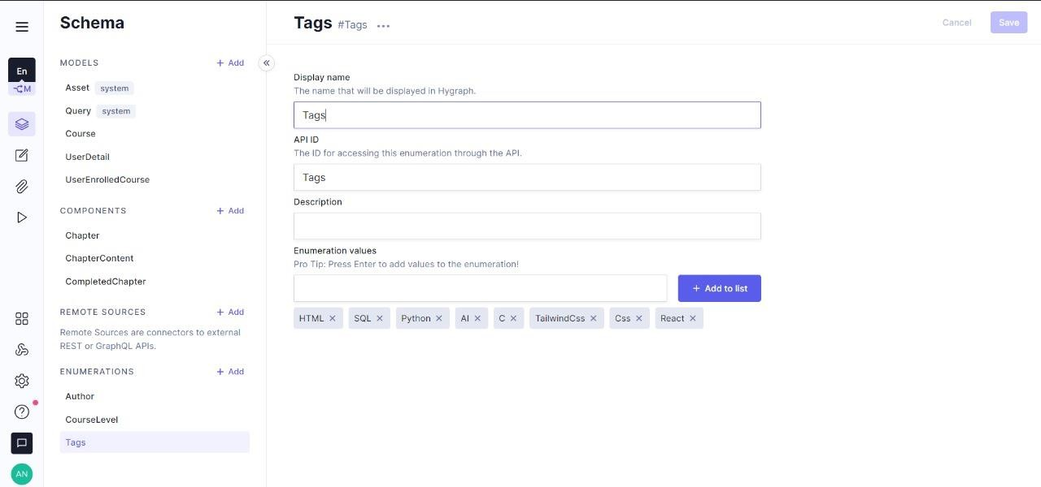

* 1. **CONTENT:**

**Course:**

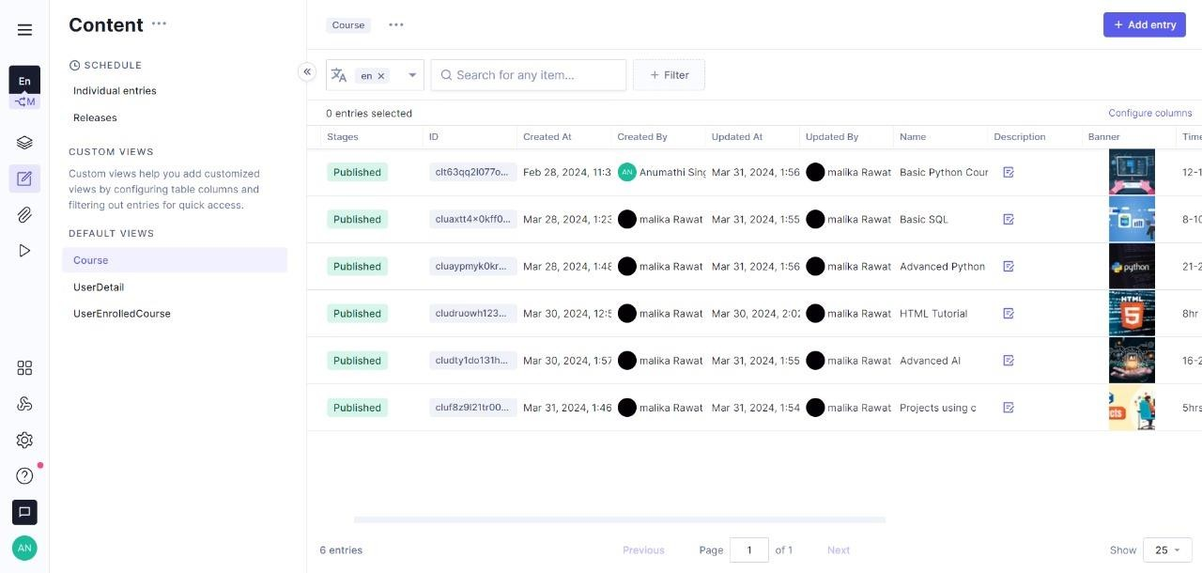

**UserDetail:**

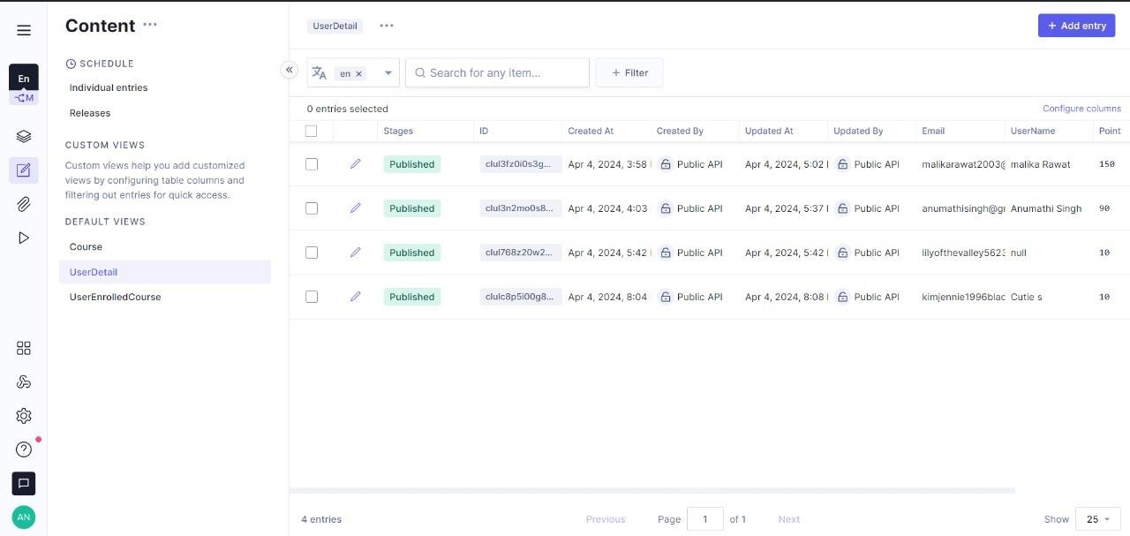

**UserEnrolledCourse:**

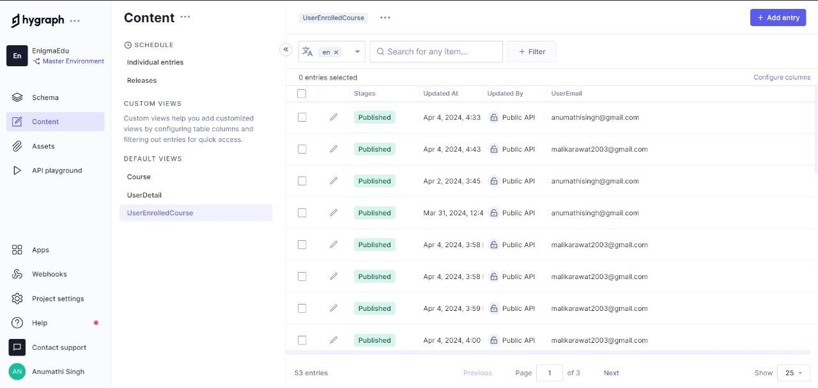

* 1. **ASSETS:**

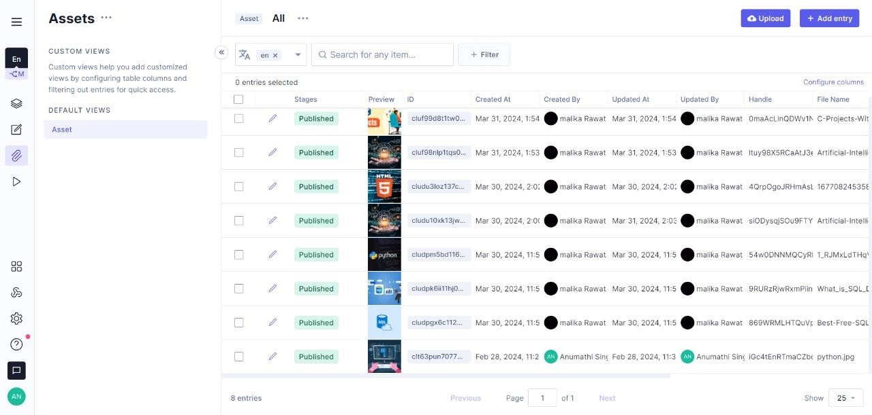

* 1. **API PLAYGROUND:**

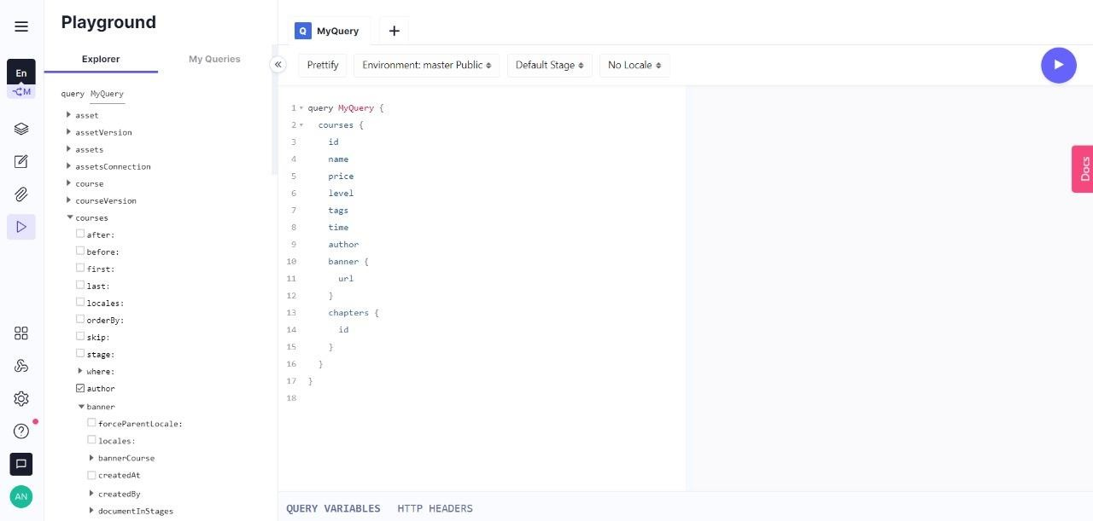

**CLERK(Authentication):**

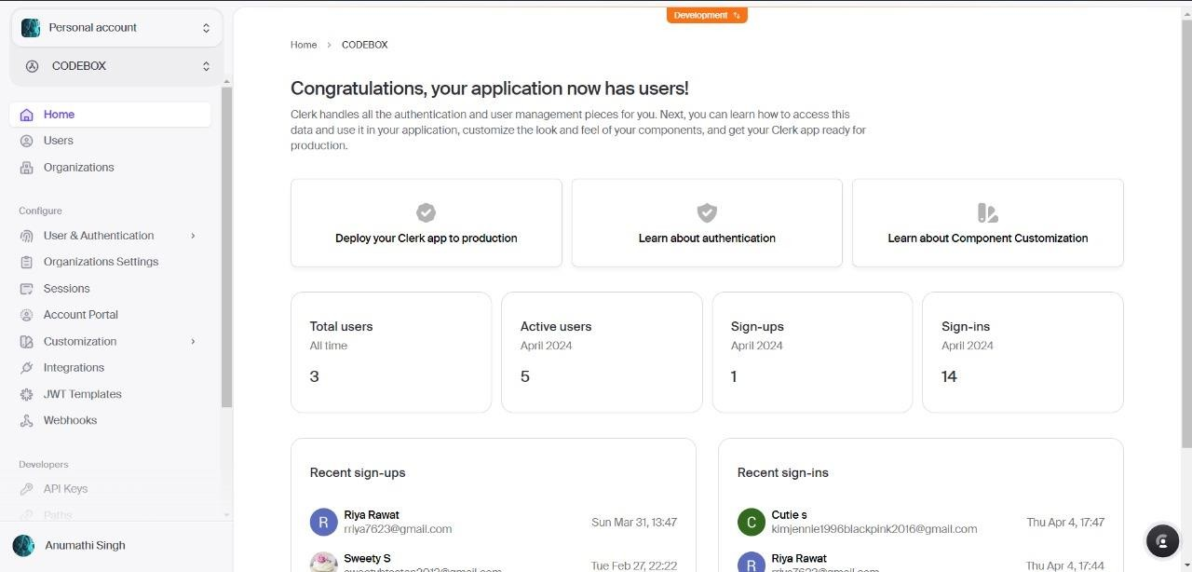

# USER SCREEN:

1. **SignIn Screen:**

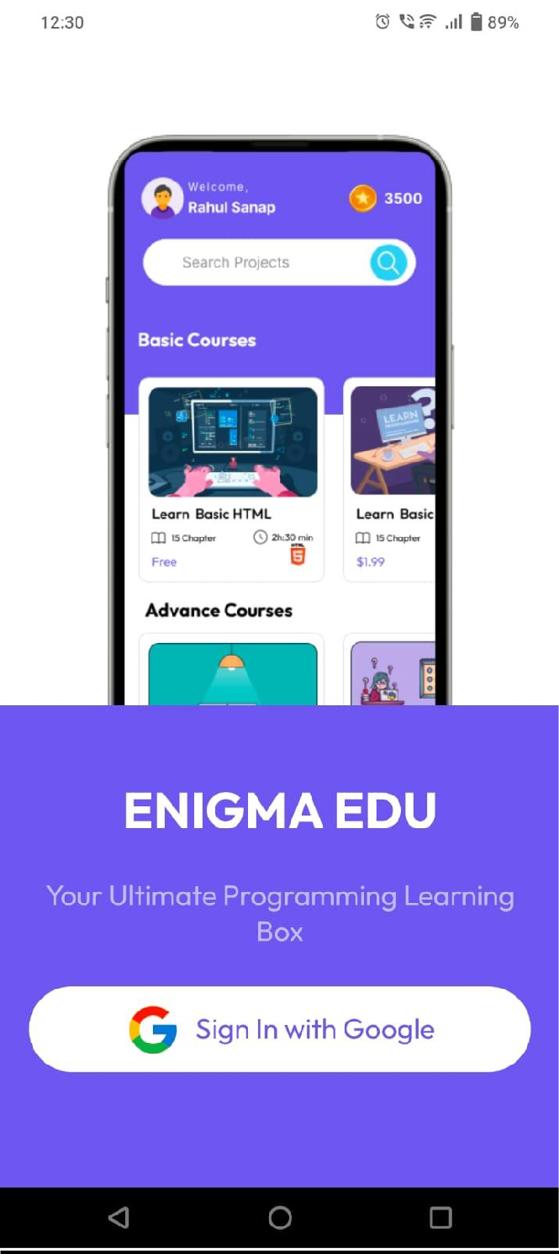

1. **HomePage:**

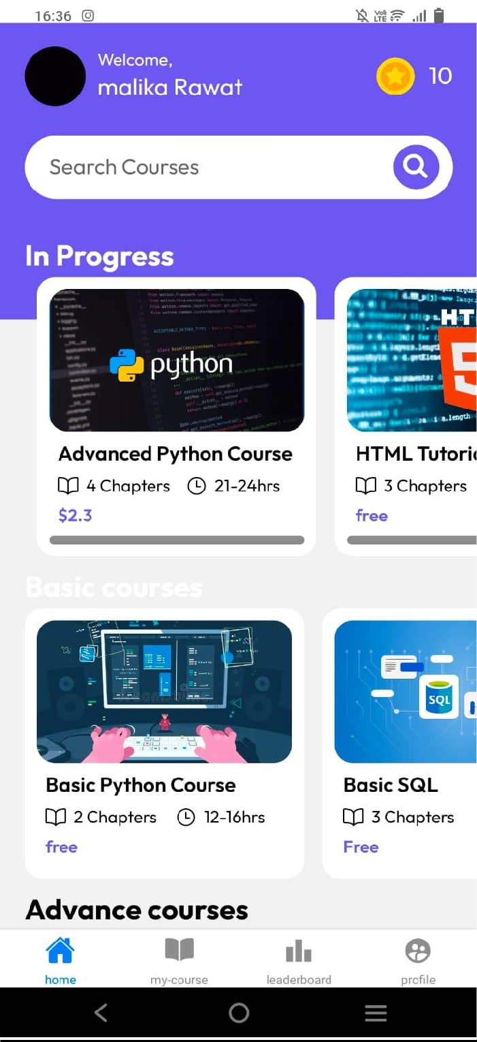

1. **MyCourses Screen:**

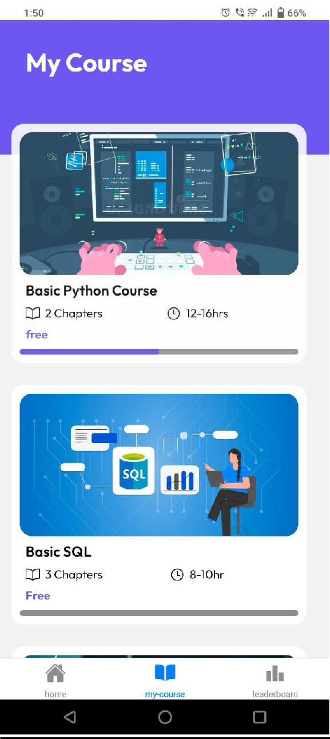

1. **CourseEnrollement:**

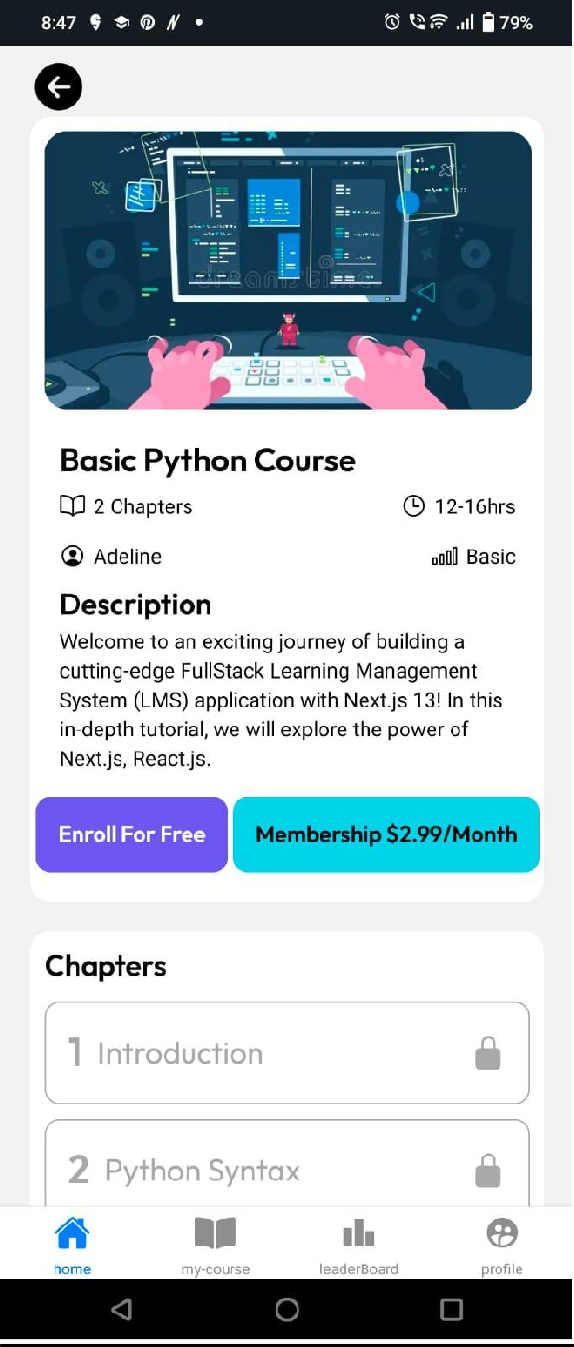

1. **CourseContent:**

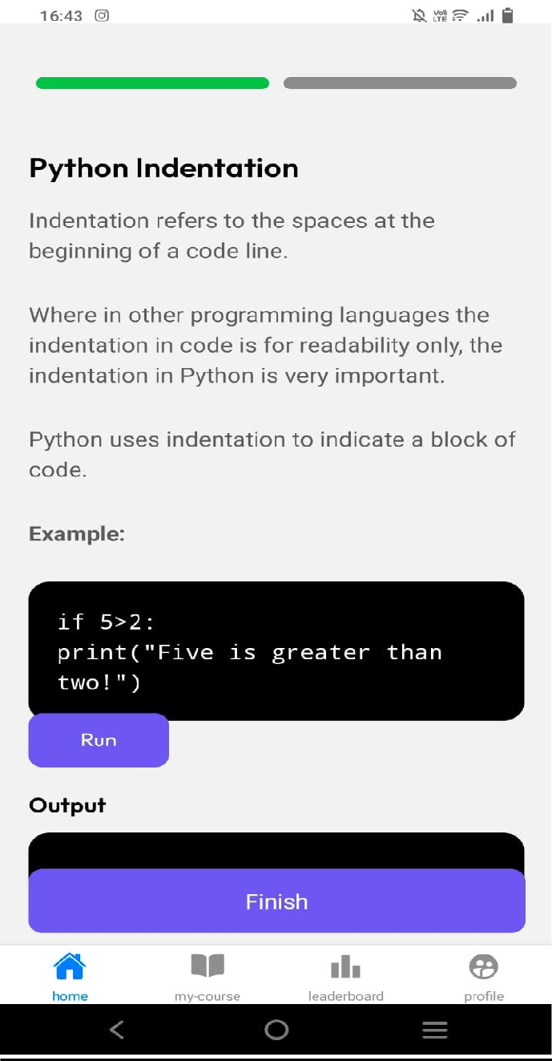

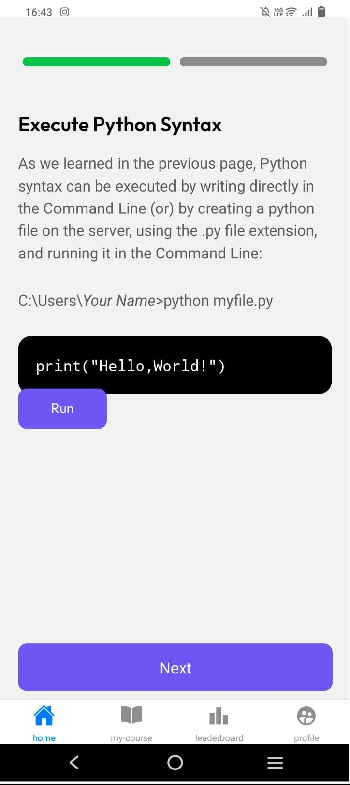

1. **LeaderBoard:**

**Singleuser:**

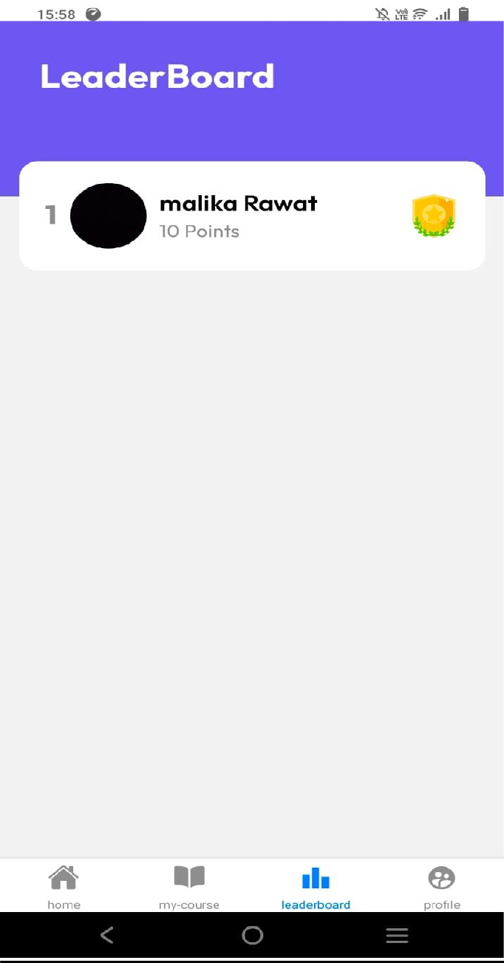

**MultipleUser:**

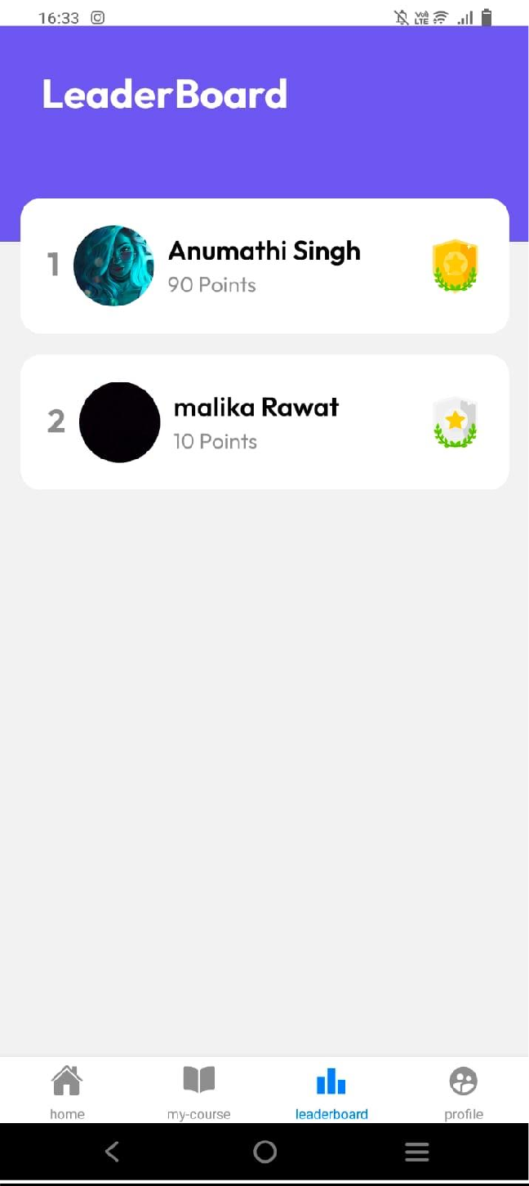

**ChangeInLeaderboard due to point:**

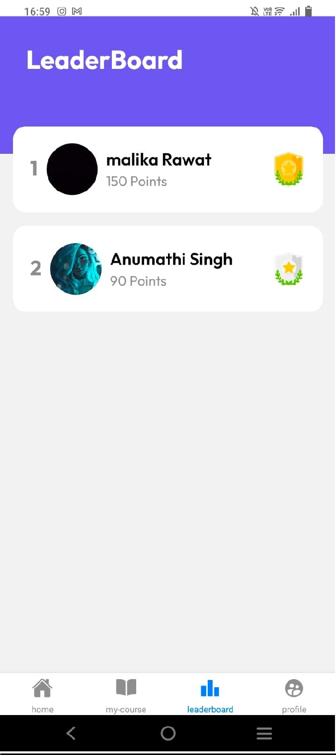

# SAMPLE CODE:

**LOGIN SCREEN:**

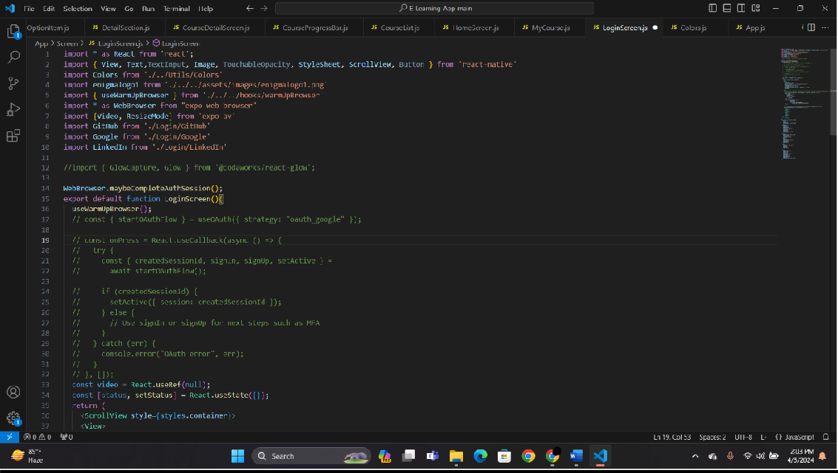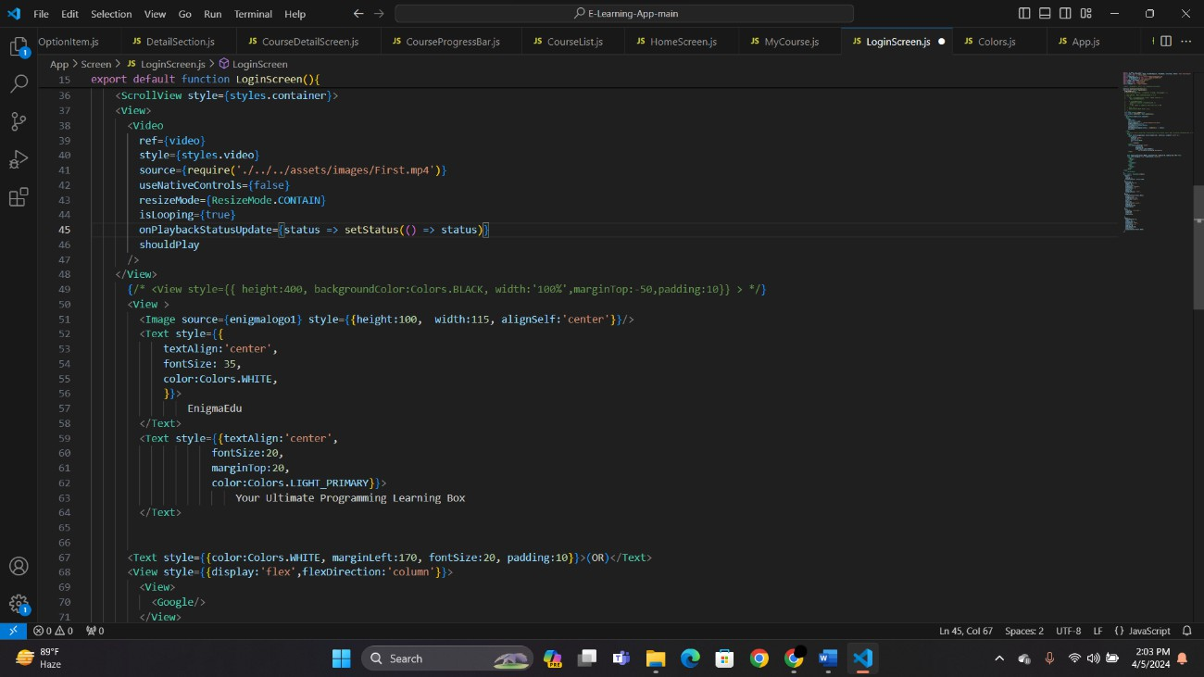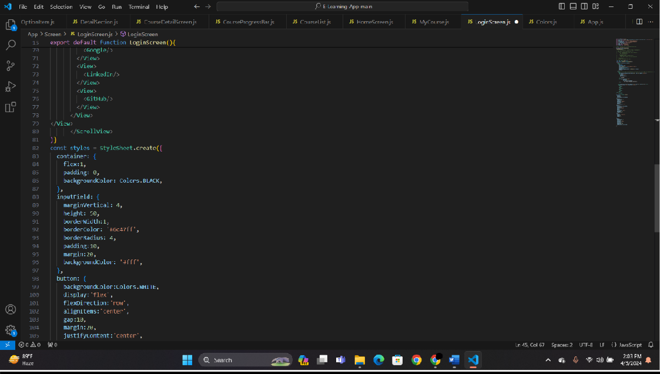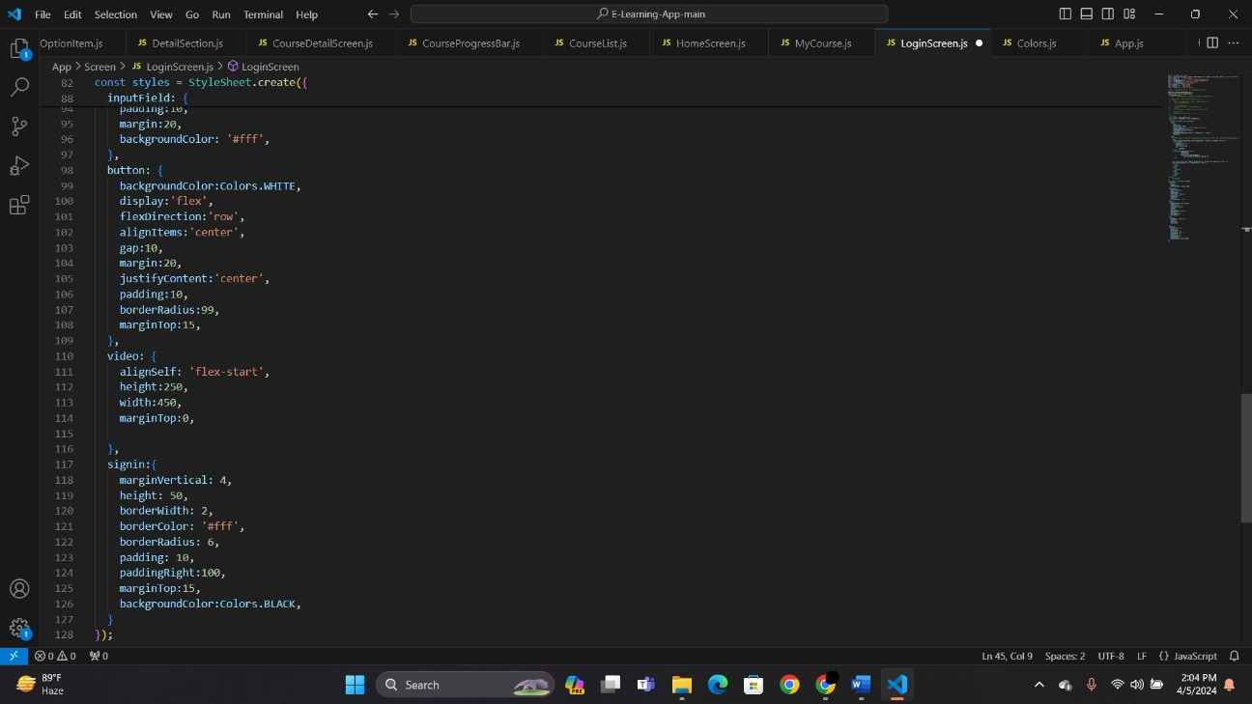

**HOMESCREEN:**

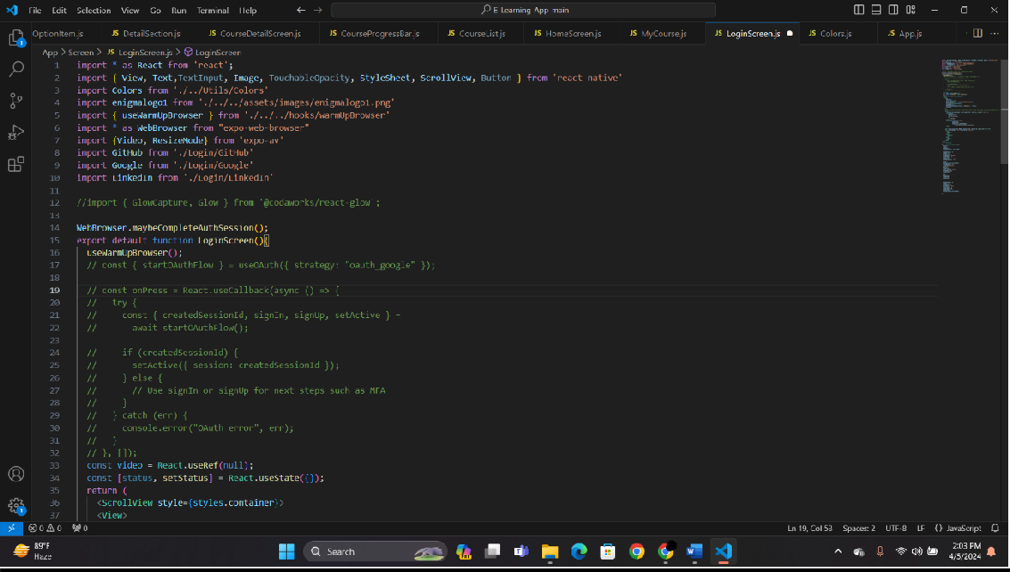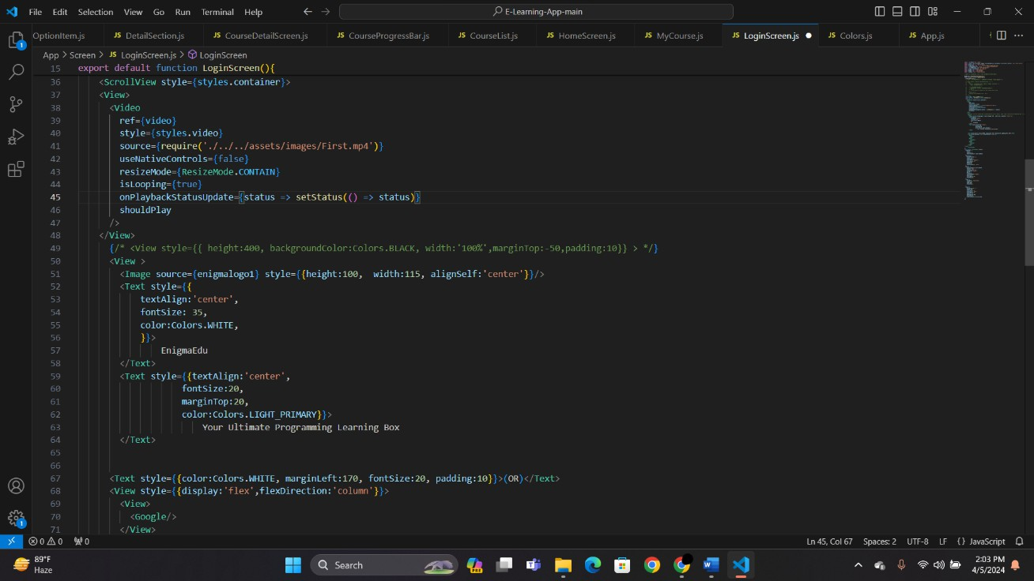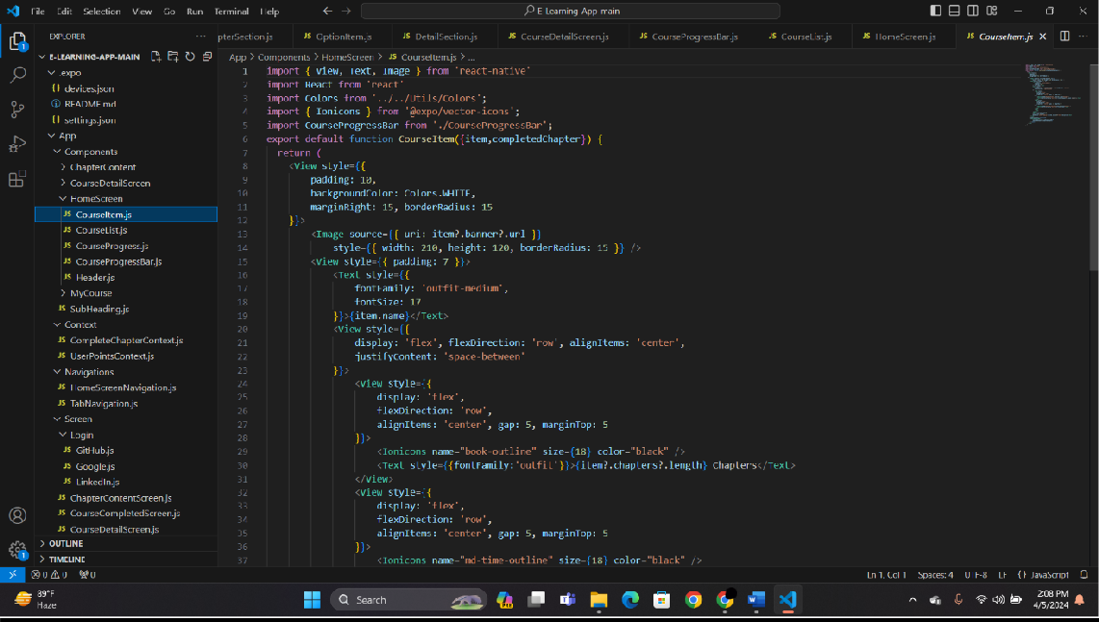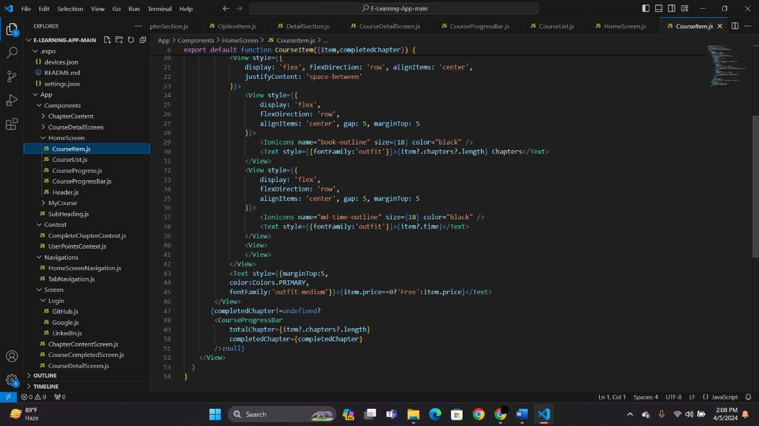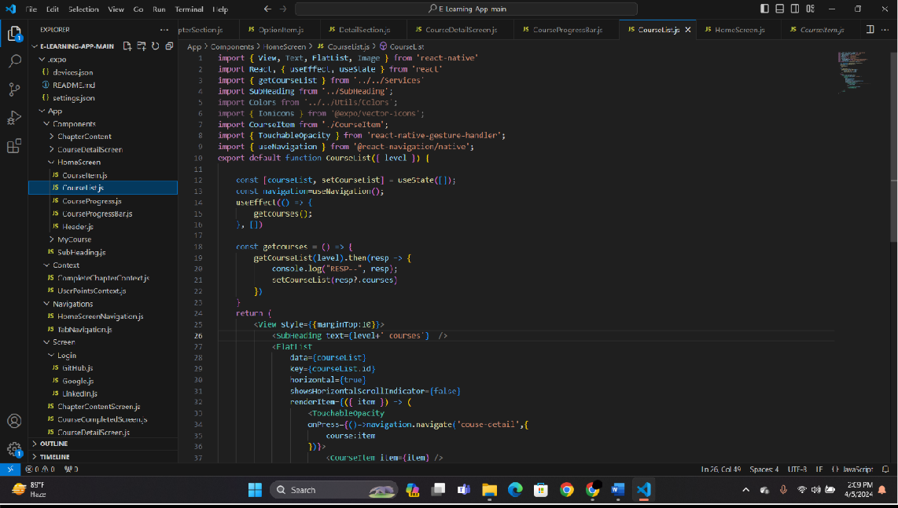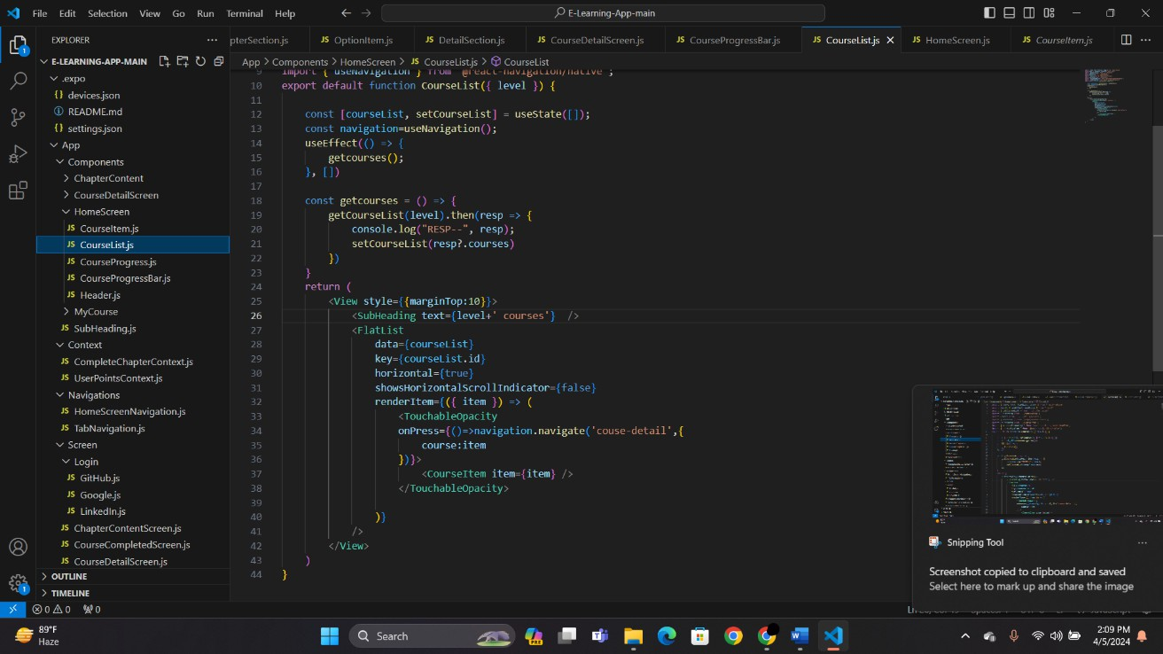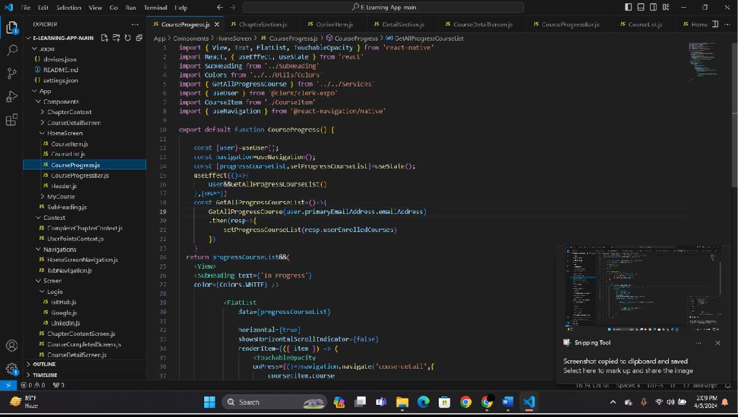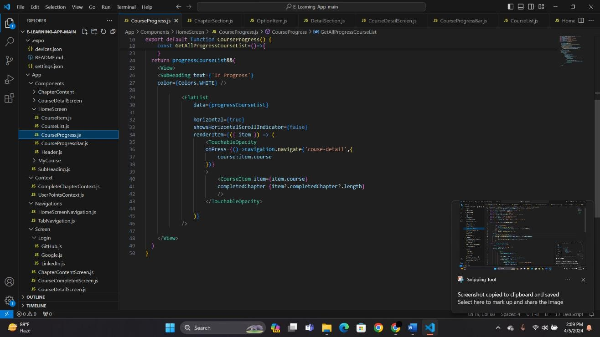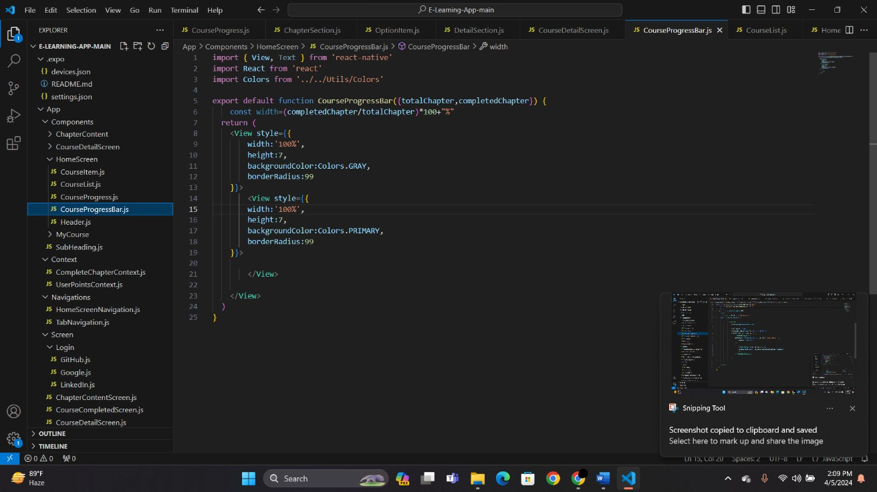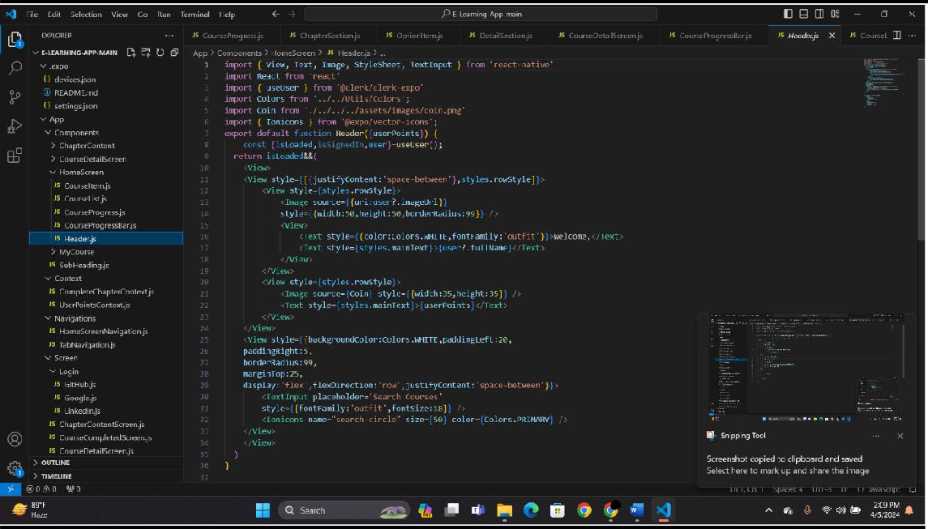

**COURSE-DETAILS:**

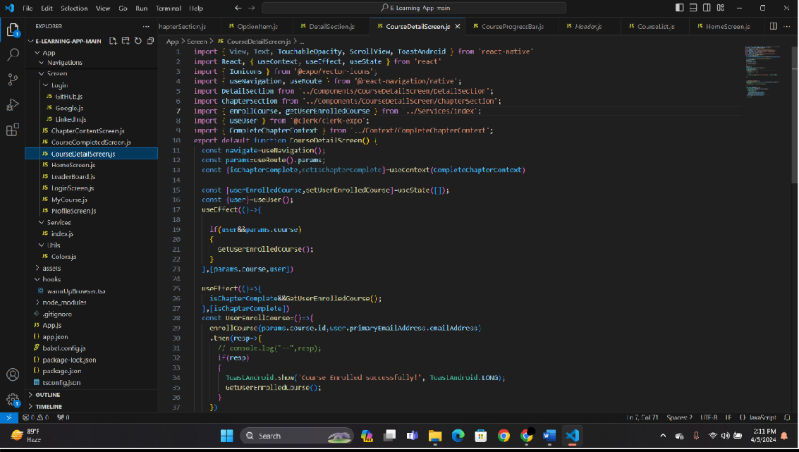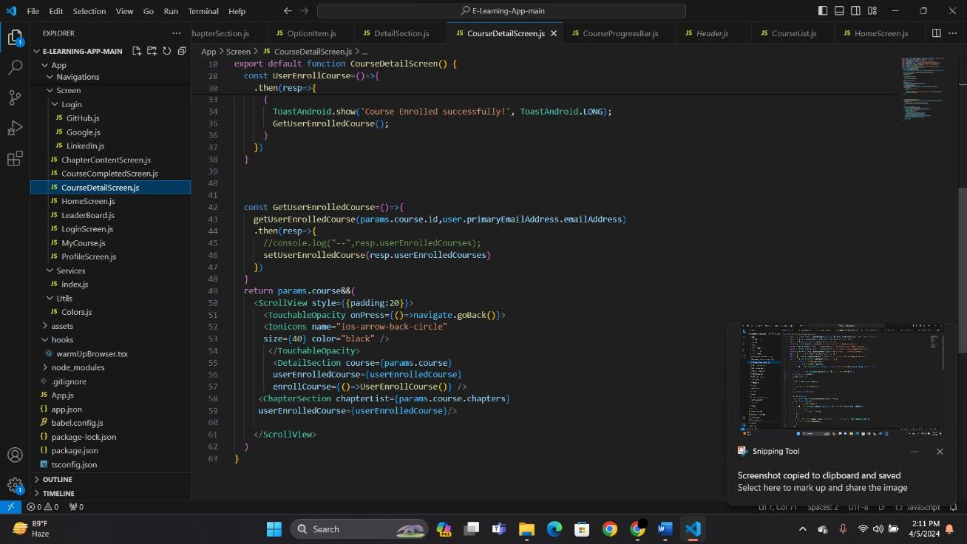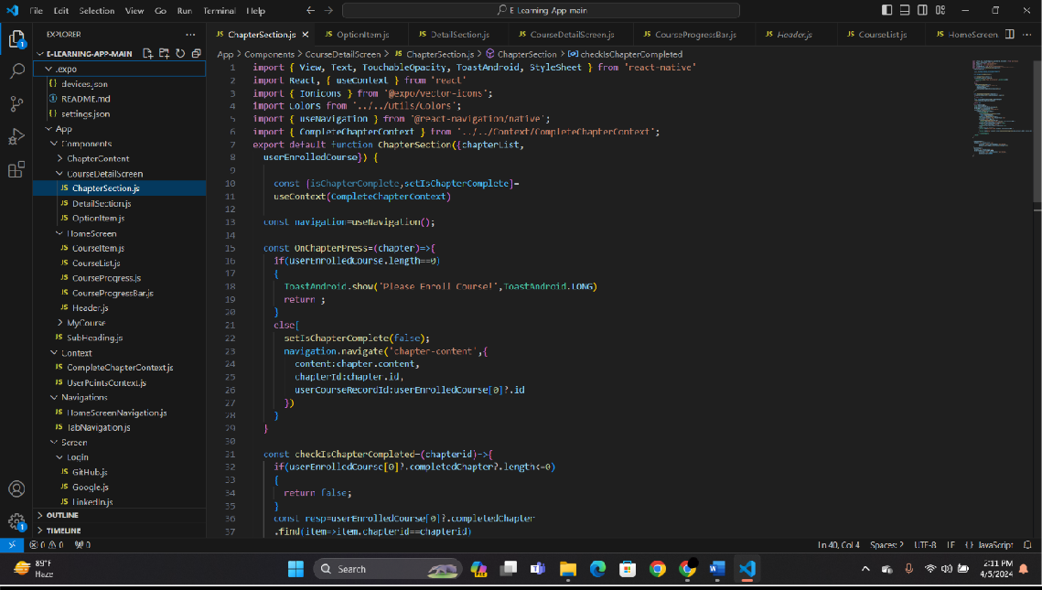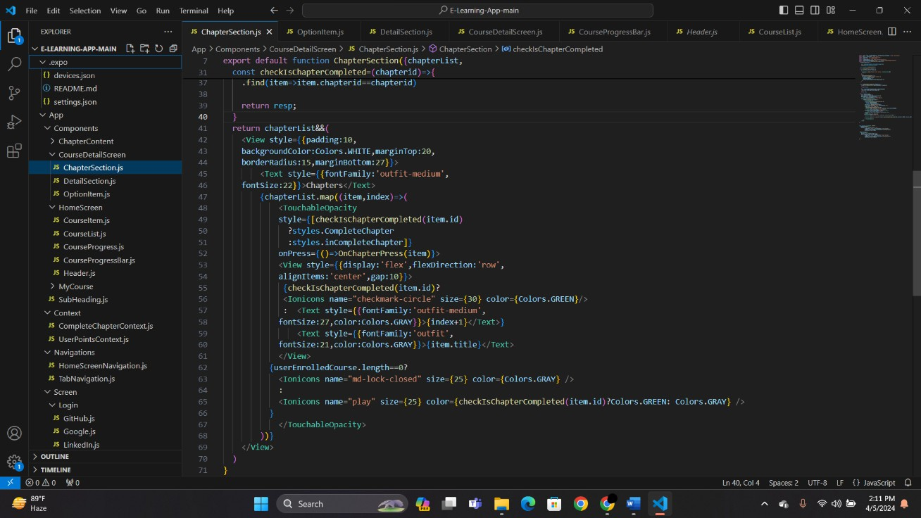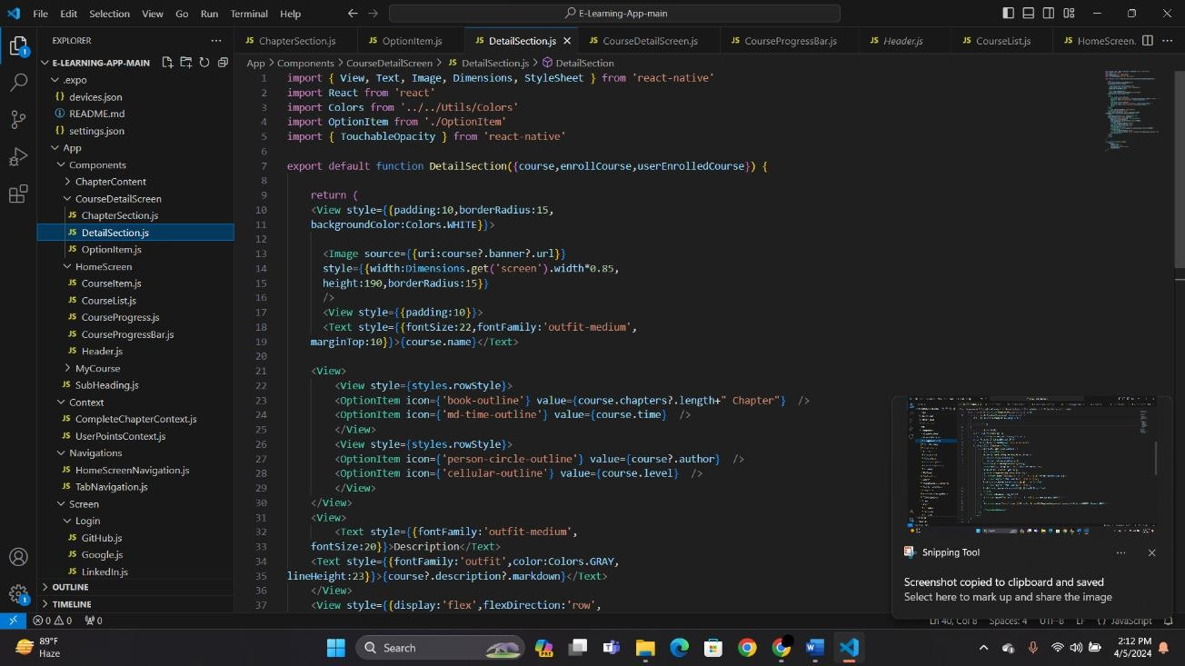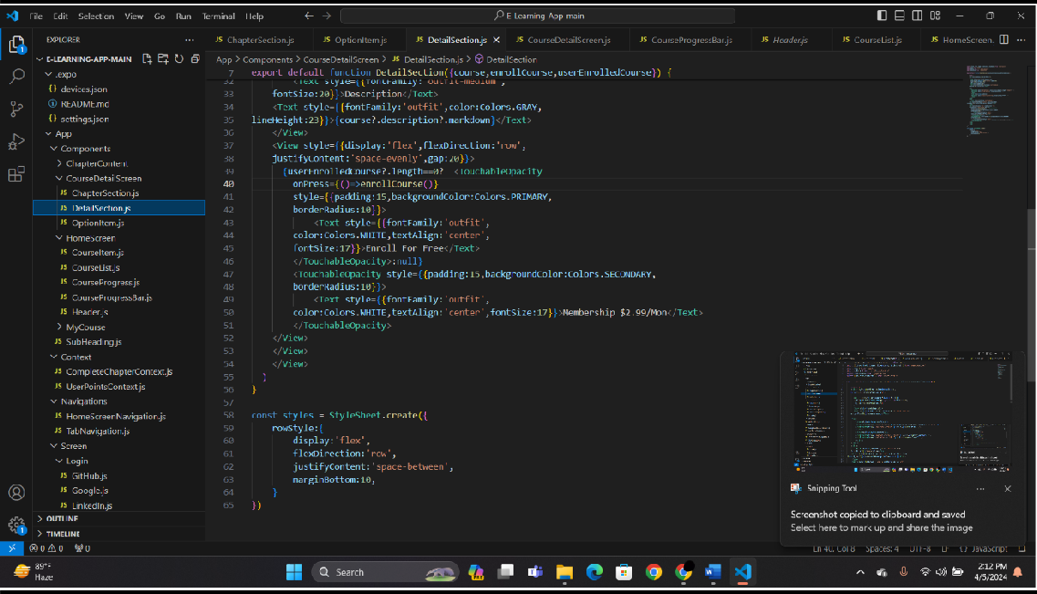

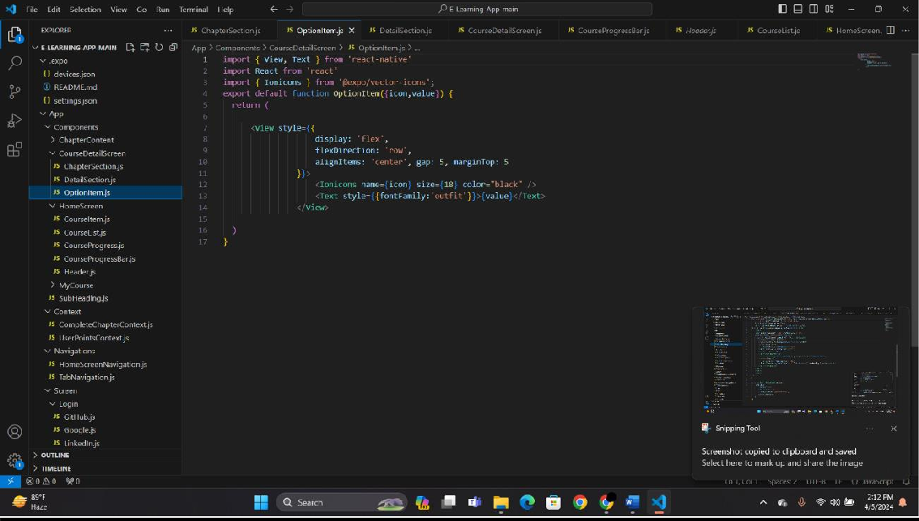

**CHAPTER-CONTENT:**

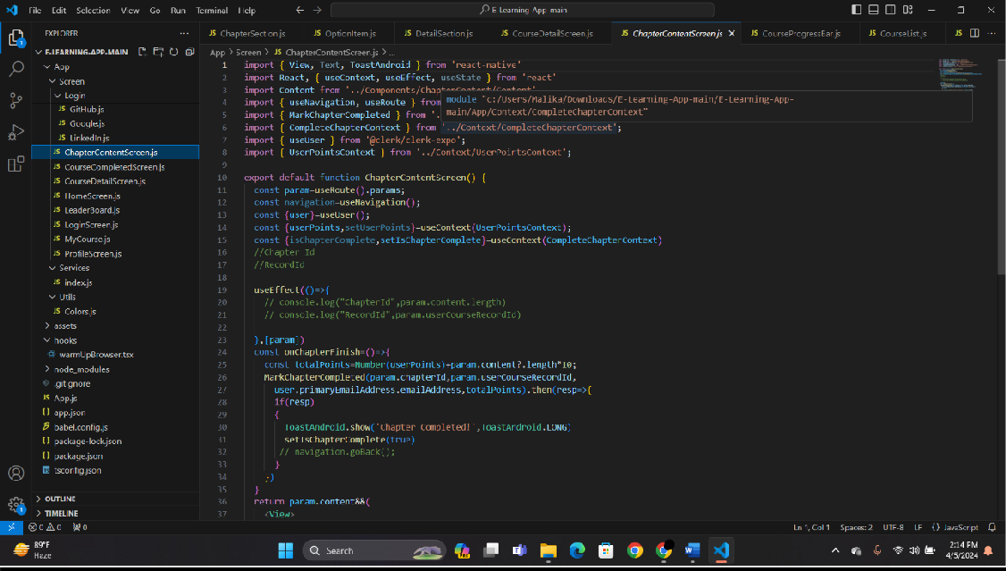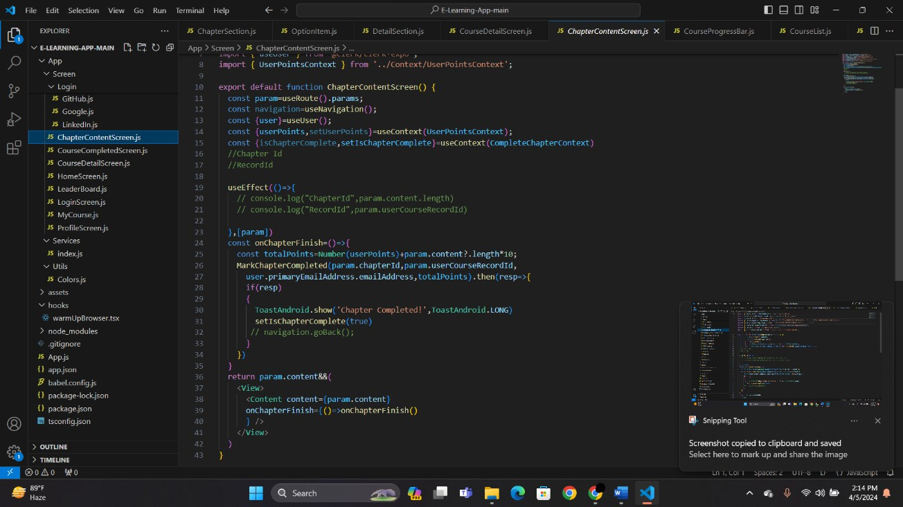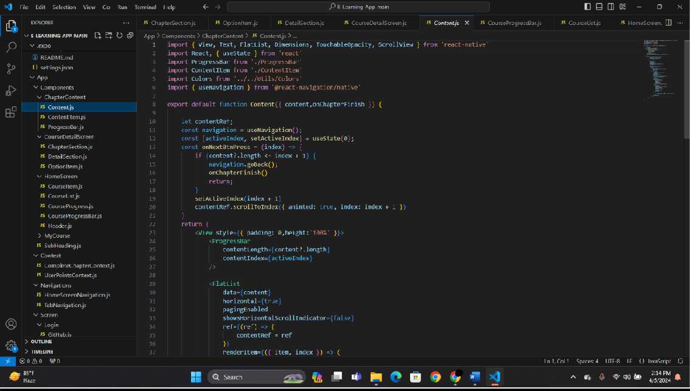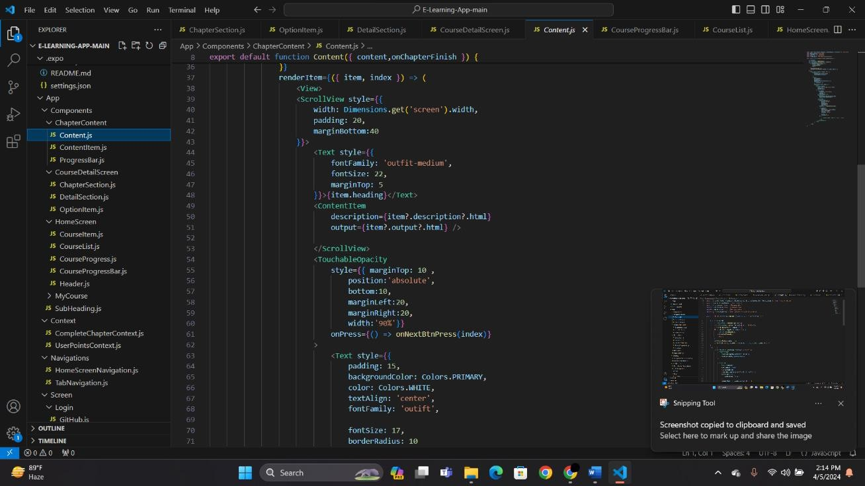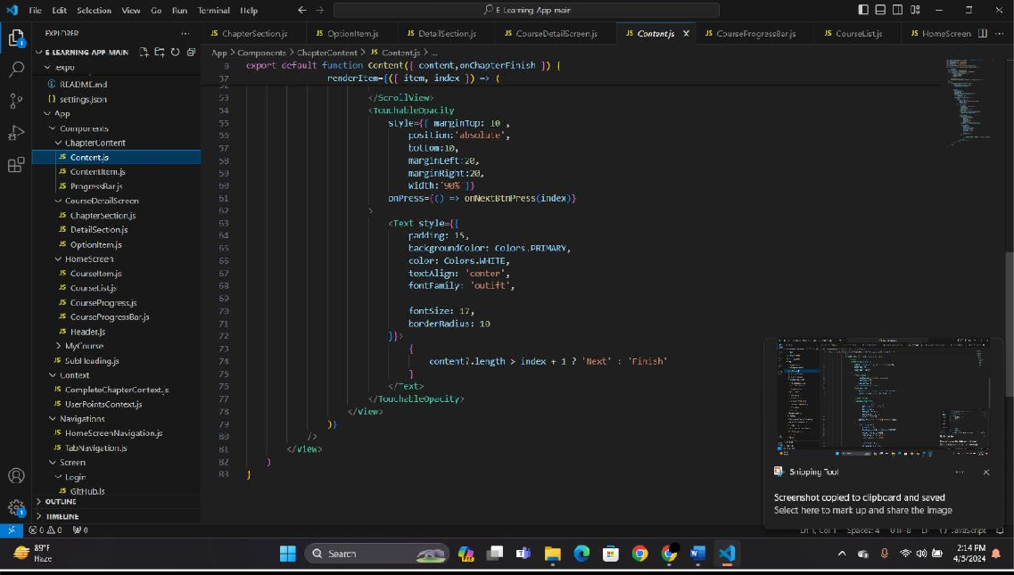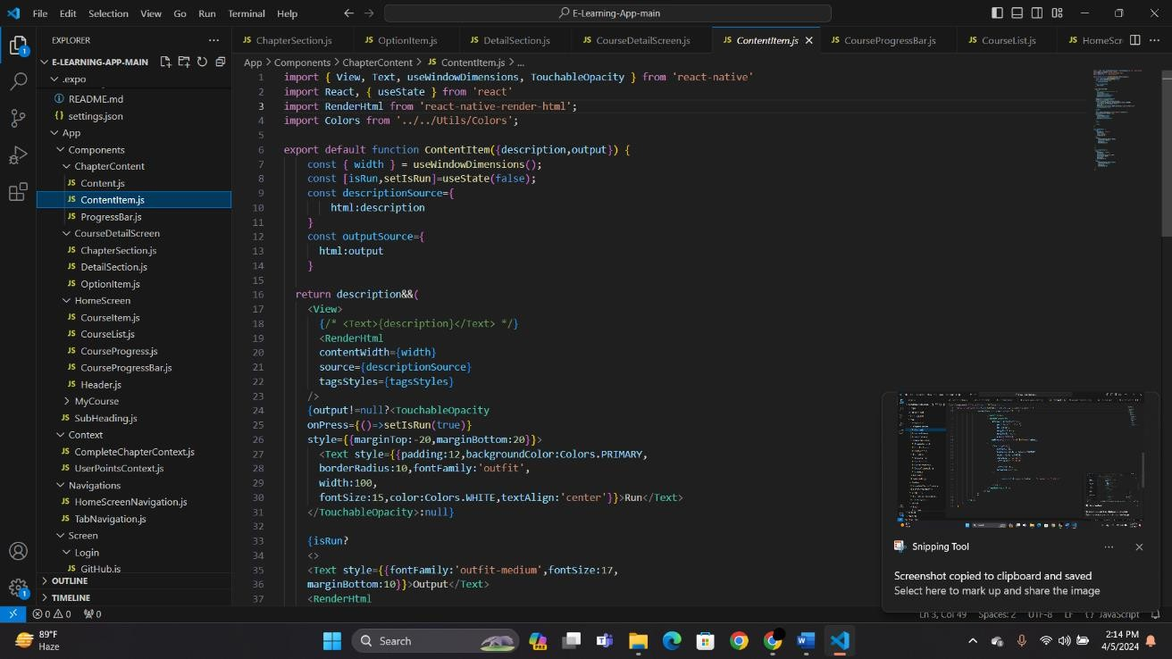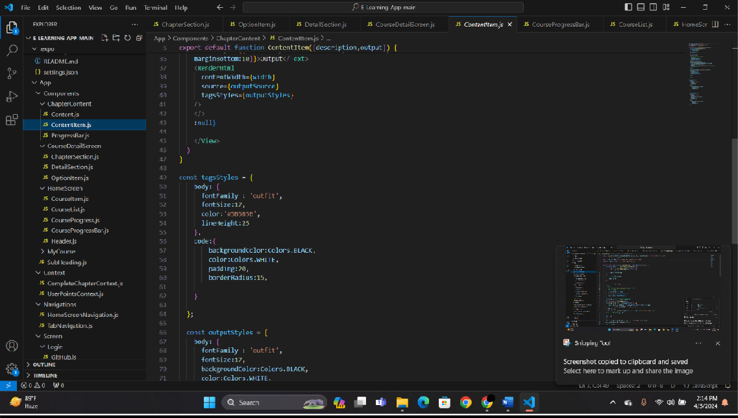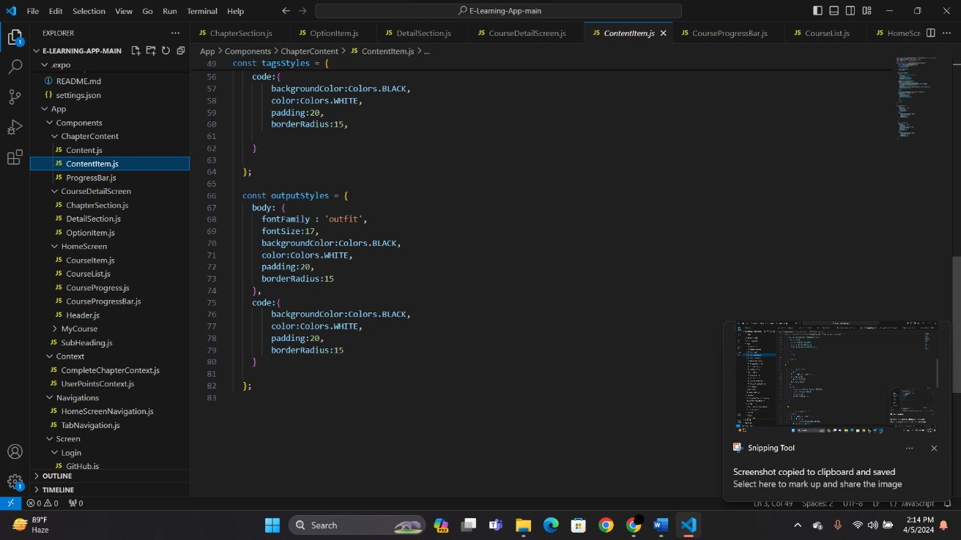

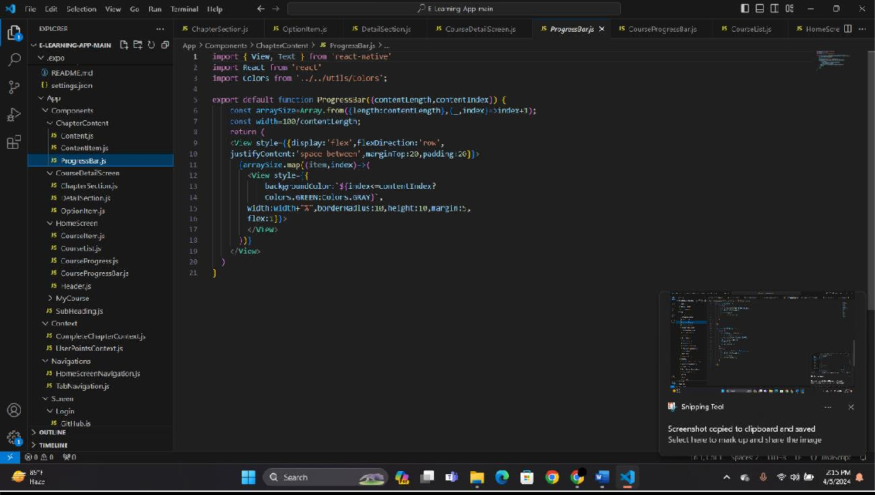

**LEADERBOARD:**

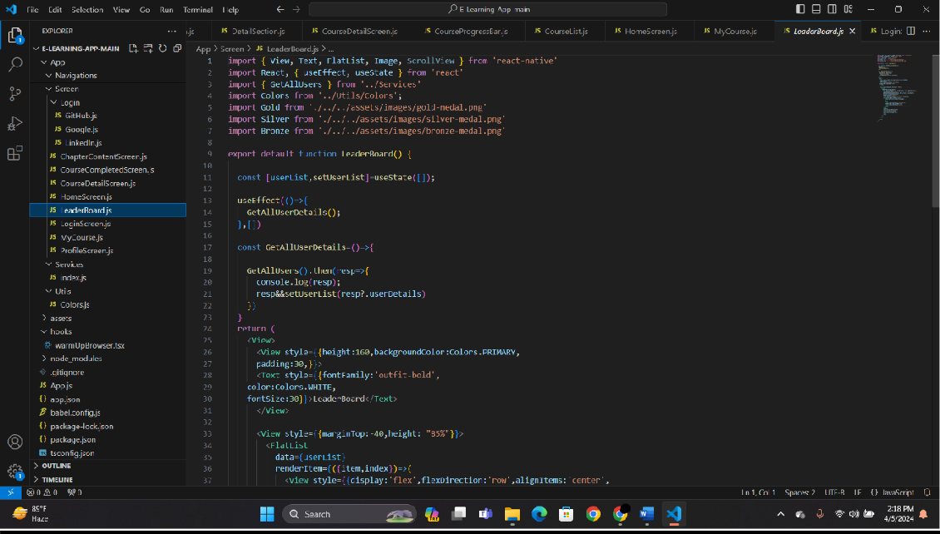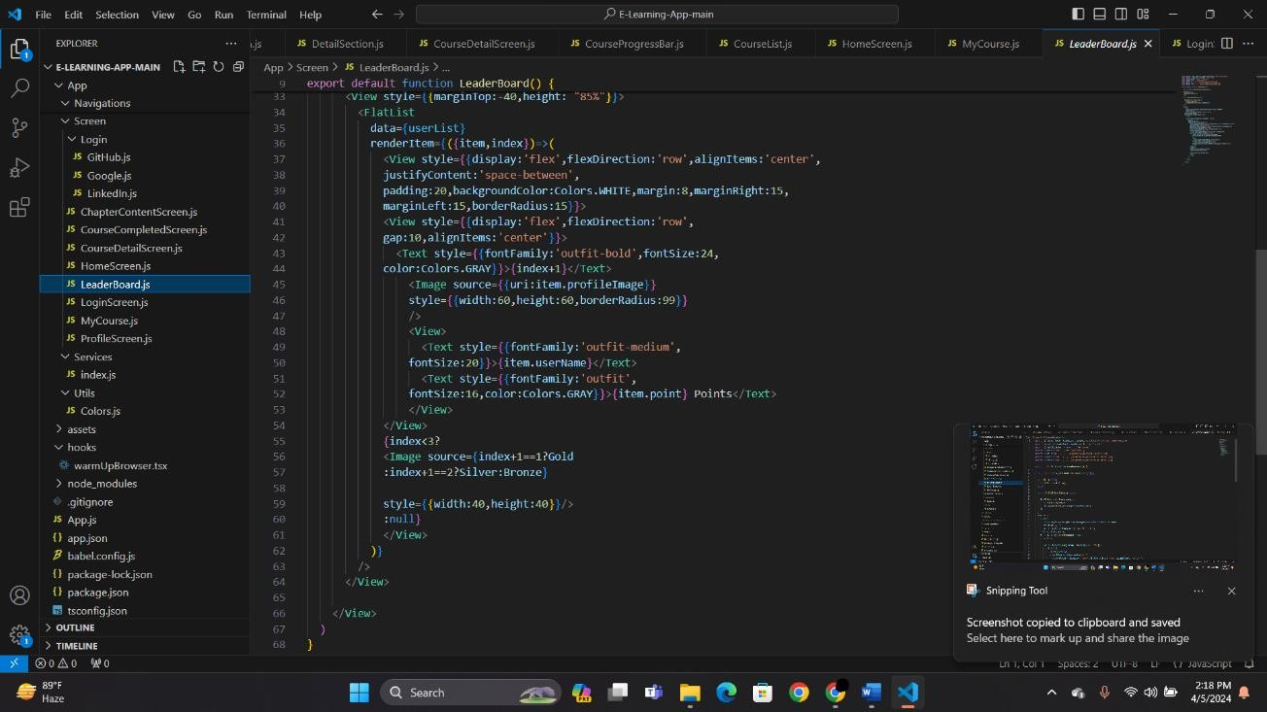

**MY-COURSE:**

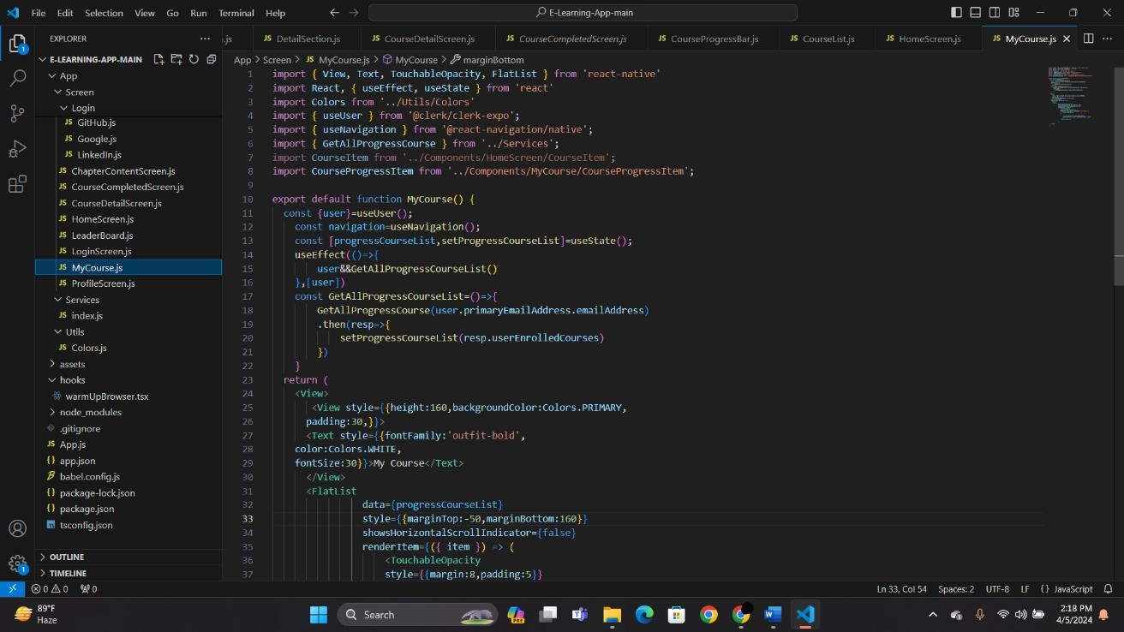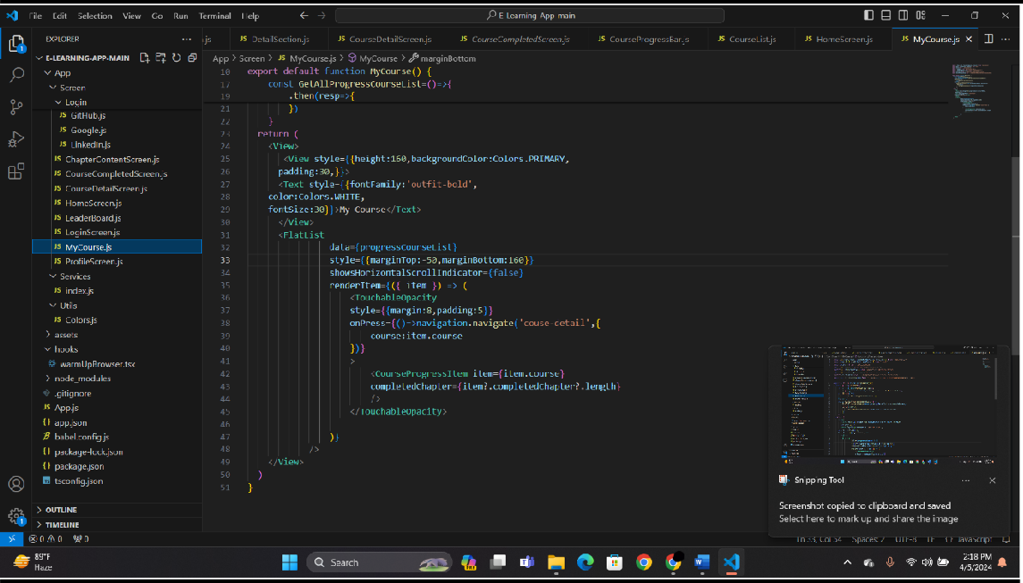

# TESTING

A process of executing a program with the explicit intention of finding errors, that is making the program fail.

**TESTING METHODOLOGIES:**

* Black Box Testing
* Software Testing
* White Box Testing

**SOFTWARE TESTING:**

It is the process of testing the functionality and correctness of software by running it. A good test case is one that has a high probability of finding a yet undiscovered error.

Software Testing is usually performed for one of two reasons:

* Defect Detection
* Reliability Estimation

**BLACK BOX TESTING:**

Applies to software system or module, tests functionality in terms of inputs and outputs at interfaces. Test reveals if the software function is fully operational with reference to requirements specification.

**WHITE/GLASS BOX TESTING:**

Knowing the internal working i.e., to test if all internal operations are performed according to the program structure and data structure. To test if all internal components have been adequately exercised.

**SOFTWARE TESTING STRATEGIES:**

A Strategy for the software testing will begin in the following order:

* Unit Testing
* Integration Testing
* Validation Testing
* System Testing

**UNIT TESTING:**

It concentrates on each unit of the software as implemented in source code and is a white box oriented. Using the component level design description as a guide, important control paths are tested to uncover errors within the boundary of the module. Unit Testing Benefits:

* Unit testing increases confidence in changing/ maintaining code. If good unit tests are written and if they are run every time any code is changed.
* Able to promptly catch any defects introduced due to the change. In addition, if codes are already made less interdependent to make unit testing possible, the unintended impact of changes to any code is less.
* Codes are more reusable. In order to make unit testing possible, codes need to be modular. This means that codes are easier to reuse.

**INTEGRATION TESTING:**

Here focus is on design and construction of the software architecture. The objective is to take unit tested components and build a program structure that has been dictated by design.

### Analogy

During the process of manufacturing a ballpoint pen, the cap, the body, the tail and clip, the ink cartridge and the ballpoint are produced separately and unit tested separately. When two or more units are ready, they are assembled and Integration Testing is performed. For example, whether the cap fits into the body or not.

**VALIDATION TESTING:**

Requirements established as part of software requirements analysis are validated against the software that has been constructed i.e., validation succeeds when software functions in a manner that can be reasonably expected by the customer.

Objective is to ensure that the product actually meets the user’s needs and that the specifications were correct in the first place. In other words, to demonstrate that the product fulfils its intended use when placed in its intended environment.

**SYSTEM TESTING:**

In this software and other system elements are tested as a whole.

### Analogy

During the process of manufacturing a ballpoint pen, the cap, the body, the tail, the ink cartridge and the ballpoint are produced separately and unit tested separately. When two or more units are ready, they are assembled and Integration Testing is performed. When the complete pen is integrated, System Testing is performed.

# IMPLEMENTATION

Implementation is the carrying out, execution or practice of a plan, to implement the project into our system we will need to perform the following operation:

* It works only on Android Mobile Phones.
* Go to updated Phone.
* Download from Playstore.
* Register.
* Open the Application login with the credentials for further usage.
* For Android Devices, Download the E-Learning App called EnigmaEdu .
* Open the app and login for further usage.

# MAINTENANCE

It is possible to develop a system that makes all the requirements of the user, User requirements keep changing as the system is being used.

Software will definitely go through change once when it is delivered to the customer.

There are a large number of reasons for the change. Change could happen due to some unpredicted input values into the system. In addition to this the change in the system directly has an effect on the software operations. The software should be implemented to accommodate changes that could be happen during the post development period some of the future enhancements that can be done to this system are:

As the technology emerges, it is possible to upgrade the system and can be adaptable to desired environment.

Because it is based on object-oriented design, any further changes can be easily adaptable.

Based on the future security issues, Security can be improved using emerging technologies

# CONCLUSION:

In conclusion, EnigmaEdu represents a powerful synthesis of modern technologies to deliver a cutting-edge e-learning experience. By leveraging Expo for rapid development, React Native for cross-platform compatibility, and HyGraph along with GraphQL for efficient data management and querying, EnigmaEdu offers a robust and scalable solution for both learners and educators alike.

Through its intuitive user interface, seamless navigation, and interactive features, EnigmaEdu empowers users to engage with educational content in a dynamic and immersive manner. Whether it's accessing courses, participating in quizzes, or interacting with peers and instructors, the app fosters a conducive environment for learning and knowledge sharing.

Moreover, EnigmaEdu's adoption of GraphQL ensures optimized data fetching and manipulation, enhancing performance and responsiveness across devices. This, combined with Expo's comprehensive toolset and React Native's flexibility, streamlines the development process and facilitates rapid iteration and updates.

As the educational landscape continues to evolve, EnigmaEdu stands at the forefront, poised to adapt and innovate in tandem with emerging technologies and user needs. With its commitment to excellence and user-centric design, EnigmaEdu paves the way for a transformative educational experience that transcends boundaries and empowerlearnersworldwide.

# BIBLIOGRAPHY

### Sites Referred:

* https:/[/www.geeksforgeeks.org/](http://www.geeksforgeeks.org/)
* <https://app.hygraph.com/>
* <https://www.javatpoint.com/>
* https:/[/www.w3schools.com/java/](http://www.w3schools.com/java/)

### Books Referred:

"React Native in Action" by Nader Dabit

“Learning GraphQL" by Eve Porcello and Alex Bank